

**A**

**TECHNICAL REPORT**

**ON**

**STUDENTS’ INDUSTRIAL WORK EXPERIENCE SCHEME (SIWES) UNDERTAKEN AT**

**AFOLABI DINEHIN AND SONS MECHANICAL ENGINEERING WORKSHOP, AKURE, ONDO STATE.**

**BY**

**OGUNSUSI DONATUS OLAWOLE**

**MEE/20/5867**

**SUBMITTED TO**

**THE DEPARTMENT OF MECHANICAL ENGINEERING   
SCHOOL OF INFRASTRUCTURE, MINERALS AND MANUFACTURING ENGINEERING**

**FEDERAL UNIVERSITY OF TECHNOLOGY AKURE**

**IN PARTIAL FULFILLMENT OF THE REQUIREMENTS FOR THE AWARD OF A BACHELOR DEGREE IN MECHANICAL ENGINEERING (B.Eng.)**

**DECEMBER, 2025.**

# ABSTRACT

This report presents a comprehensive account of the activities, technical exposure, and competencies gained during my six-month SIWES training at Afolabi Dinehin and Sons Mechanical Engineering Workshop, Akure, Ondo State. The report begins with an overview of SIWES, its objectives, and its importance in bridging theoretical knowledge with practical industrial application. A brief profile of the workshop is provided, outlining its areas of specialization, organizational structure, and operational processes.

The technical core of the report documents the hands-on experience acquired in various automotive machining and repair operations. These include engine block reboring, crankshaft regrinding, cylinder head servicing, valve seat cutting, milling, lathe machining, precision drilling, injector pump disassembly and calibration, and general mechanical fabrication tasks. Each operation is discussed with emphasis on the underlying engineering principles, procedural steps, tools and machines used, safety protocols, and key lessons learned.

The report concludes with observations on the relevance of the SIWES programme to Mechanical Engineering training, alongside recommendations to the workshop, the institution, and the SIWES coordinating bodies. The experience significantly enhanced my technical competence, problem-solving ability, work discipline, and understanding of real-world automotive engineering practice.

# CERTIFICATION

This is to certify that **OGUNSUSI DONATUS OLAWOLE**, a Mechanical Engineering student of the Federal University of Technology Akure with Matriculation number **MEE/20/5867** had his Students’ Industrial Work Experience Scheme (SIWES) at **AFOLABI DINEHIN AND SONS MECHANICAL ENGINEERING WORKSHOP**, Akure, Ondo State between the period of May 2025 and October 2025.

............................................ ....................................

**Prof. A.O. Akinola** Date

H.O.D. Mechanical Engineering

............................................ ....................................

**Ogunsusi Donatus Olawole**  Date

# DEDICATION

This report is dedicated to the Lord Almighty, for His unending Grace and Mercy upon me. I also dedicate this to my ever-loving and supporting parents, Mr. and Mrs. Ogunsusi for their constant support and love throughout this journey.

# ACKNOWLEDGEMENT

I give thanks to **God Almighty** for His guidance, protection, and grace throughout the duration of my SIWES programme and the successful completion of this report. His strength and favour made every stage of this experience possible.

I would also like to express my profound gratitude to my lovely family, **Mr. and Mrs. Ogunsusi,** for their unwavering moral and financial support. Their encouragement and belief in my abilities have remained a constant source of motivation. I am equally grateful to my brothers, **Damian, Dennis, and Dominic**, whose support and understanding greatly contributed to my success during this period.

My sincere appreciation extends to my friends and colleagues with whom I undertook the training. Their camaraderie, teamwork, and spirit of friendship enriched the entire experience and created a supportive learning environment.

I also wish to express my deep gratitude to **Mr. Oluwaremi Oluboba**, my industry-based supervisor, for his exceptional guidance, mentorship, and patience. His expertise, constructive feedback, and practical insights significantly shaped my learning and improved the technical skills I gained throughout the programme.

.

Finally, I am thankful to the entire team at **Afolabi Dinehin and Sons Mechanical Engineering Workshop** for providing me with the opportunity to acquire hands-on experience in machining operations, injector pump repair, welding, and fabrication. Their willingness to teach and share knowledge played a crucial role in strengthening my practical understanding of mechanical engineering processes.

I remain sincerely grateful to everyone who contributed to making my SIWES experience productive, insightful, and impactful.

# TABLE OF CONTENT

ABSTRACT ii

CERTIFICATION iii

DEDICATION iv

ACKNOWLEDGEMENT v

TABLE OF CONTENT vi

CHAPTER ONE 1

1.0 INTRODUC TION 1

1.1 BACKGROUND INFORMATION ON STUDENTS’ INDUSTRIAL WORK EXPERIENCE SCHEME 1

1.2 AIMS AND OBJECTIVES OF SIWES 1

1.3 ROLES OF STUDENTS DURING SIWES 2

1.4 BENEFITS OF SIWES 3

1.1. SCOPE OF SIWES 4

CHAPTER TWO 5

2.0 COMPANY PROFILE 5

2.1 BACKGROUND INFORMATION ON THE COMPANY: 5

2.2 THE DIFFERENT SECTIONS IN THE WORKSHOP: 6

2.3 ORGANIZATION OF THE COMPANY: 8

CHAPTER THREE 9

3.0 DESCRIPTION OF WORK EXPERIENCE 9

3.1 WORKSHOP SAFETY 9

3.2 CRANKSHAFT REGRINDING SECTION 10

3.2.1 INTRODUCTION TO CRANKSHAFT REGRINDING 10

3.2.2 PURPOSE AND IMPORTANCE OF CRANKSHAFT REGRINDING 12

3.2.3 DESCRIPTION OF THE CRANKSHAFT GRINDING MACHINE 13

3.2.4 PRE-GRINDING INSPECTIONS AND MEASUREMENTS 17

3.2.5 CRANKSHAFT GRINDING PROCEDURE 18

3.2.6 POST-GRINDING INSPECTION AND QUALITY CHECKS 21

3.2.7 SAFETY PRECAUTIONS WHILE PERFORMING CRANKSHAFT GRINDING 23

3.3 REFRIGERATION SECTION: FABRICATION OF ICE-BLOCK MACHINE 25

3.3.1 INTRODUCTION TO ICE-BLOCK MACHINES 25

3.3.2 MATERIALS USED IN FABRICATION 26

3.3.3. REFRIGERATION CYCLE AND COOLING PRINCIPLES IN ICE‑BLOCK PRODUCTION 29

3.3.4 FABRICATION AND ASSEMBLY PROCESS OF THE ICE-BLOCK 34

3.3.5 COMMON FAULTS IN ICE-BLOCK MACHINES AND THEIR CAUSES 37

3.3.6 PREVENTIVE MAINTENANCE PRACTICES FOR ICE-BLOCK MACHINES 39

3.3.7 REPAIR TECHNIQUES FOR REFRIGERANT LEAKAGE 41

3.3.8 SAFETY MEASURES DURING REPAIR AND MAINTENANCE 44

3.4 ENGINE BLOCK BORING AND REBORING SECTION 46

3.4.1 INTRODUCTION TO CYLINDER BORING AND REBORING 46

3.4.2 MATERIALS AND TOOLS USED IN CYLINDER BORING AND REBORING 48

3.4.3 MEASUREMENT STANDARDS AND TOLERANCES 51

3.4.4 PRE-BORING INSPECTION AND MEASUREMENTS 51

3.4.5 CYLINDER BORING PROCEDURE 55

3.4.6 SAFETY MEASURES DURING CYLINDER BORING OPERATIONS 64

3.5 OTHER SECTIONS AND OPERATIONS CARRIED OUT 65

3.5.1 INJECTORS AND INJECTOR CALIBRATION 65

3.5.2 MILLING OPERATIONS 66

CHAPTER FOUR 68

4.0 CONCLUSION AND RECOMMENDATIONS 68

4.1 CONCLUSION 68

4.2 RECOMMENDATION 69

REFERENCE: 70

**LIST OF FIGURES**

Figure 1: Dial-gauge setup illustrating crankshaft run-out measurement 18

Figure 2: Setup of crankshaft mounted between headstock and tailstock 19

Figure 3: Grinding procedure 20

Figure 4: Hermetic Compressor 29

Figure 5: Vapor-compression cycle diagram 31

Figure 6: Labelled diagram showing the internal structure of the hermetic compressor 32

Figure 7: Capillary Tube 33

Figure 8: Micrometer screw gauge / Figure 9: Dial Bore Guage 50

Figure 10: Engine cylinder showing scoring defects 52

Figure 11: Illustration of ridge wear on piston top ……………………………………………...53

Figure 12: Dry Cylinder Sleeves / Figure 13: Wet Cylinder sleeves 60

**LIST OF PLATES**

Plate 1: Inline engine crankshaft/Plate 2: Inline and V-engine crankshafts 11

Plate 3: Crankshaft showing taper wear 13

Plate 4: Crankshaft grinding machine 15

Plate 5: Outer frame of fabricated Ice-block machine Plate 6: Fabricated ice-block machine 26

Plate 7: Evaporator Tubes 28

Plate 8: Condenser coil / Plate 9: Oxy-acetylene gas torch 28

Plate 10: Rivet Gun 29

Plate 11: Installation of the compressor and refrigerant lines 36

Plate 12: Final assembly/Quality assurance operations 37

Plate 13: Cylinder surface showing discoloration and wear due to heat 47

Plate 14: Cylinder surface showing wear marks 47

Plate 15: Engine block with sleeved cylinder configuration 47

Plate 16: Engine block with standard cylinder configuration 48

Plate 17: Vertical Boring machine 49

Plate 18: Engine block setup on machine bed / Plate 19: Engine Crane/Lift 50

Plate 20: Engine cylinder showing corrosion pitting ……………………………………………52

Plate 21: Cylinder inner surface showing cracks 53

Plate 22: Engine block mounted and clamped on vertical boring machine bed 56

Plate 23: Using bore gauge to verify finished cylinder diameter 59

Plate 24: Injector Calibration Machine / Plate 25: Injector Calibration operations 66

Plate 26: Milling Machine 67

**LIST OF TABLES**

Table 1: Common Boring Problems and Corrections 59

Table 2: Comparison: Sleeving vs. Standard Reboring 63

# CHAPTER ONE

# 1.0 INTRODUCTION

## 1.1 BACKGROUND INFORMATION ON STUDENTS’ INDUSTRIAL WORK EXPERIENCE SCHEME

The Students' Industrial Work Experience Scheme (SIWES) was established in 1973 by the Industrial Training Fund (ITF) to address the challenge of inadequate practical skills among graduates of Nigerian tertiary institutions, which hindered their employment in local industries. The program was designed as a skill development initiative aimed at exposing and preparing university and higher institution students, particularly those in their penultimate year, for the realities of industrial employment post-graduation. By serving as a bridge between academia and the professional world, SIWES offers students the opportunity to gain practical, hands-on experience with equipment and machinery that are often unavailable in their educational institutions.

Initially, the program was fully funded and supported by the ITF. However, financial constraints led to the withdrawal of ITF funding in 1978. Subsequently, the federal government delegated the administration of SIWES to the National Universities Commission (NUC) and the National Board for Technical Education (NBTE) in 1979. In November 1984, the federal government reassigned the supervision and implementation of the scheme back to the ITF. Since July 1985, the federal government has been solely responsible for financing the scheme.

.

## 1.2 AIMS AND OBJECTIVES OF SIWES

The primary objectives of the Students Industrial Work Scheme are as follows:

I. Enable students in higher education institutions to gain practical industrial skills and hands-on experience relevant to their approved fields of study.

II. Prepare students for the industrial work environment they are expected to encounter after graduation.

III. Expose students to diverse techniques and methods for operating equipment and machinery within their academic institutions.

IV. Provide students with opportunities to apply their theoretical knowledge in real-world settings, effectively linking theory to practice.

V. Strengthen collaboration between employers and the educational system to better prepare students for careers in industrial and commercial sectors.

VI. Support a seamless transition from academic studies to professional careers, enhancing students' chances of securing employment.

## ROLES OF STUDENTS DURING SIWES

Students undergoing industrial training experience during SIWES are expected to:

1. Report for duty daily and promptly. They are also expected to work during expected working hours excluding public holidays.
2. Responsible to the supervisor in-charge of the respective sections.
3. Obey rules and regulations of the organization to which the students are attached.
4. Be polite in relationship with supervisors, other workers as well as colleagues.
5. Show strong attitude and positive disposition to work and try to identify with regular workers by showing a sense of belonging.

## BENEFITS OF SIWES

SIWES enables students to enjoy the following benefits:

1. Appreciate work method and gain experience in handling equipment and machinery which may not be available in the institution.
2. Develop and enhance personal attribute such as critical thinking, creativity, initiative, resourcefulness, leadership, time management, presentation skills and interpersonal communication.
3. Bridge the gap between the knowledge acquired in institutions and the relevant production skills required in work organizations.
4. Appreciate the role of professions in their various fields as the creators of change and wealth as well as indispensable contributors to growing economy and national development.
5. Appreciate the connection between their courses of study and other related disciplines in the production of goods and services.

## SCOPE OF SIWES

The scope of SIWES is to bridge the gap between theoretical education and practical industry experience. It offers students exposure to real-world work environments, helping them develop technical and soft skills, exposing students to the latest technologies and equipment in their fields, facilitating the transition from classroom learning to real-world work experience and preparing students for the demands and expectations of the labour market. SIWES enhances understanding of workplace culture, builds professional networks, and fosters partnerships between educational institutions and industries. Ultimately, SIWES improves employability by equipping students with the skills and experience needed for their careers.

SIWES is typically undertaken during 400 level second semester and vacation period. It is mandatory for students in certain disciplines, such as engineering, technology, and applied sciences.

# CHAPTER TWO

# 2.0 COMPANY PROFILE

## 2.1 BACKGROUND INFORMATION ON THE COMPANY:

Afolabi Dinehin and Sons Mechanical Engineering Workshop, founded in 1984, has been a hub of innovation and precision in the mechanical engineering industry for over 40 years. Situated along the Ilesa/Owo expressway in Akure, Ondo State, the workshop is widely recognized for its expertise and dependable services.

Strategically located, the workshop boasts a comprehensive array of machinery, including lathes, milling machines, drilling machines, and boring machines, among others. These tools are systematically arranged within the facility to optimize efficiency and accessibility for the skilled technicians who utilize them.

The workshop's dedicated team of professionals handles a wide variety of projects, from designing and fabricating diverse items to repairing industrial and domestic machinery. Their extensive knowledge spans key areas of mechanical engineering, enabling them to execute tasks with precision and efficiency.

Afolabi Dinehin and Sons Mechanical Engineering Workshop is committed to serving both industrial and domestic clients. Whether manufacturing components for commercial equipment or repairing household appliances, the workshop delivers every project with meticulous attention to detail and unwavering dedication.

In addition to its technical expertise, the workshop plays an active role in the local community through its apprenticeship programs and opportunities for industrial training. These initiatives aim to nurture the next generation of engineers and craftsmen, ensuring the continuation of its legacy and its continuous dedication to training young aspiring engineers through the engineering industry.

## 2.2 THE DIFFERENT SECTIONS IN THE WORKSHOP:

In the workshop environment, a system of skilled labor and specialized sections harmonize to ensure the proper operation of machinery and vehicles. These distinct sections serve as the backbone of the workshop, each contributing its unique expertise to deliver top-notch products and services to customers. Details on each section are as follows:

1. **Machining Section:**

At the core of precision engineering, this section is equipped with a diverse range of advanced tools, including lathes, milling machines, drilling machines, boring machines, and grinding machines. Organized into three distinct subsections, it features a dedicated boring section for all boring operations, a grinding section exclusively for grinding machines, and a third area housing lathes, drilling, and milling machines. Skilled machinists expertly operate these tools to produce precise components, primarily engine parts, in compliance with strict engineering standards. Through processes such as turning, milling, drilling, and grinding, the section ensures the accurate shaping and finishing of metal parts to meet exact specifications.

1. **Injector Section:**

Specializing in the intricate realm of fuel injection systems, this section is devoted to the repair and maintenance of fuel injectors utilized in automotive and industrial engines. Expert technicians painstakingly disassemble, clean, inspect, and reassemble injectors, meticulously ensuring optimal performance. Equipped with specialized equipment such as injector testing machines and nozzle testers, they diagnose and rectify injector issues with precision and finesse.

1. **Welding and Fabrication Section:**

Here, skilled welders and fabricators wield their expertise to manipulate various metal materials, fashioning structures, frames, and components with meticulous precision. Electric arc welding reigns supreme as the primary welding process, seamlessly joining metal parts together. Meanwhile, fabrication entails a myriad of techniques, including cutting, bending, and shaping metal sheets and profiles to forge custom parts and assemblies tailored to exact specifications.

1. **Auto Repair Section**:

Focused on the intricate mechanics of vehicles, this section specializes in diagnosing and rectifying mechanical issues plaguing automobiles. Technicians adeptly perform routine maintenance tasks such as oil changes, brake inspections, and tire replacements, ensuring the smooth operation of vehicles on the road. Armed with creative techniques and specialized equipment, they meticulously identify and address complex engine and transmission system problems, restoring vehicles to peak performance. In essence, the workshop's diverse sections converge to form a cohesive unit, driven by a collective commitment to precision and excellence in engineering and automotive services. Through collaboration and expertise, they ensure the seamless functioning of machinery and vehicles, delivering unparalleled quality to satisfied customers.

## 2.3 ORGANIZATION OF THE COMPANY:

The overseeing of the workshop is handled by Mr. Oluwaremi Oluboba, who is the manager of the affairs of the workshop, my supervisor in the course of the training and the technical head of the injector section. The other sections in the workshop are overseen by technical heads who are experts on their respective fields and are responsible for coordinating other lower ranking technicians and training of apprentice

# CHAPTER THREE

## 3.0 DESCRIPTION OF WORK EXPERIENCE

At Afolabi Dinehin and Sons Mechanical Engineering LTD, I had hands-on technical and analytical experience in very important fields of the mechanical world – automobile, HVAC systems, metal and material fabrication and testing, etc. From engine parts analysis and repair to developing new parts, to building refrigeration and hydro-efficient systems from scratch, I gained extensive experience in all these sections and fields and was able to confidently use these analytical and practical skills to solve real-life engineering problems.

## 3.1 WORKSHOP SAFETY

To operate on the workshop floor, I was made to go through the company’s safety guidelines

and was provided with Personal Protective Equipment (PPE) to ensure my safety. Some of the

safety guidelines include:

1. Always ensure to use the prescribed PPE for any tool or equipment being operated (goggles, gloves, boots, and or ear protection).
2. Ensure a clean work environment and immediately wipe oil spills to avoid slip and fall accidents.
3. Ensure to operate all equipment and tools with knowledge of its operational procedure

including emergency shutdown.

1. Demonstrate precaution and attention while operating the automobile lifts to avoid poorly

fixing the base supports.

1. Avoid the misuse of tools or the use of tools for a purpose not intended.

## 3.2 CRANKSHAFT REGRINDING SECTION

### 3.2.1 INTRODUCTION TO CRANKSHAFT REGRINDING

The crankshaft is one of the most critical rotating components in an internal combustion engine. It converts the linear reciprocating motion of the pistons into rotary motion, which is ultimately transmitted to the drivetrain to produce usable mechanical work. Due to continuous loading during engine operation—particularly the forces generated during combustion strokes—the crankshaft operates under intense mechanical stress, high rotational speeds, and repetitive bending and torsional loads. Over time, these factors, combined with inadequate lubrication, bearing wear, overheating, or contamination of engine oil, can lead to deterioration of the crankshaft’s main and crankpin journals. Common defects include scoring, scratches, taper, ovality, cracks, and uneven wear, all of which compromise the engine’s efficiency and structural integrity.

Crankshaft regrinding is an essential precision machining process used to restore worn or damaged crankshaft journals to their proper geometric specifications. Instead of replacing the entire crankshaft—which is often expensive and sometimes difficult to source during engine rebuilds—regrinding ensures that the journal surfaces are returned to perfect circularity, correct dimensional accuracy, and appropriate surface finish suitable for hydrodynamic lubrication. This process involves removing controlled amounts of material from the journal surfaces to achieve a standardized undersize dimension that matches available bearing inserts. By restoring uniform oil clearance and ensuring smooth rotational motion, crankshaft regrinding significantly improves the performance, reliability, and lifespan of an engine after overhaul.

Within automotive and heavy-duty engine workshops such as **Afolabi Dinehin and Sons Mechanical Engineering Workshop**, crankshaft regrinding serves as a central operation in engine rebuilding and maintenance. It is performed using specially designed precision grinding machines equipped with abrasive grinding wheels, steady rests, and high-accuracy measuring tools. The procedure demands skill, attention to detail, and strict adherence to engineering tolerances, as even minor errors can lead to catastrophic engine failure. During my industrial training, I had the opportunity to observe and participate in crankshaft inspection, measurement, mounting, grinding, and polishing operations under experienced machinists. This exposure provided a solid understanding of the importance of accuracy, machine setup, lubrication principles, and the role of crankshaft reconstruction in mechanical engineering practice.

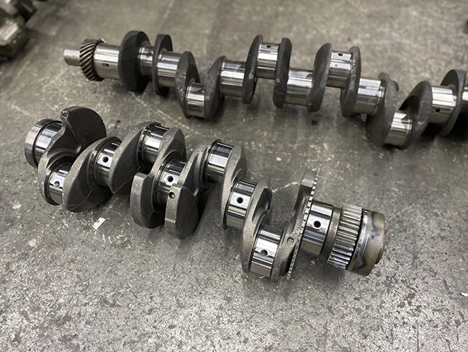 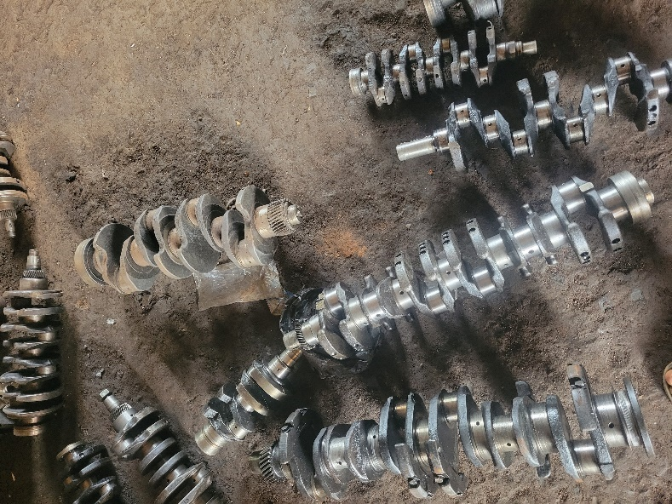

Plate : Inline engine crankshaft Plate : Inline and V-engine crankshafts

### 3.2.2 PURPOSE AND IMPORTANCE OF CRANKSHAFT REGRINDING

Crankshaft regrinding is an essential restorative machining process carried out to ensure the continued reliability and performance of an internal combustion engine. Over prolonged engine operation, crankshafts experience mechanical wear due to continuous rotation, high loading forces, abrasion from contaminated oil, and occasional lubrication failure. These conditions cause the crankshaft journals—both main journals and crankpins—to gradually lose their perfectly round geometry, resulting in defects such as taper, ovality, scratches, and scoring. Any deviation from the manufacturer’s specified tolerances directly affects the oil clearance between the crankshaft journals and the bearing shells. Excessive clearance leads to reduced lubrication film thickness, increased vibration, lower oil pressure, and eventual bearing failure. Regrinding is therefore performed to correct these dimensional errors and restore the crankshaft’s structural and functional integrity.

The primary purpose of crankshaft regrinding is to achieve a journal surface that is perfectly round, smooth, and concentric with the crankshaft’s centerline, while maintaining the correct undersize dimensions dictated by bearing manufacturers. When journals are reground, controlled amounts of material are removed to achieve standardized undersize values such as **0.25 mm**, **0.50 mm**, or **1.00 mm**. Corresponding undersize bearings are then fitted during engine reassembly. This ensures precise lubrication clearances, promotes the formation of a stable hydrodynamic oil film, and minimizes friction and heat generation during engine operation. In turn, the engine runs more smoothly, operates quietly, and maintains stable oil pressure.

Another key importance of crankshaft regrinding lies in its cost-effectiveness and sustainability. Instead of replacing a worn or slightly damaged crankshaft—which is usually expensive and sometimes difficult to procure—regrinding allows the existing crankshaft to be reused without compromising reliability. This process extends the lifespan of the crankshaft while meeting the functional requirements of the engine after an overhaul. Furthermore, the regrinding process also allows for correction of structural defects such as misalignment, journal surface burn marks, and improper fillet radii, which can lead to crankshaft fatigue or catastrophic engine failure if not properly addressed.

From a mechanical engineering perspective, crankshaft regrinding is a precision operation that contributes significantly to the overall engine rebuilding workflow. By restoring correct journal geometry, the process strengthens the engine’s mechanical balance, reduces vibration, and ensures uniform power transmission. During my industrial training at *Afolabi Dinehin and Sons Mechanical Engineering Workshop*, the importance of this process became evident, as the regrinding operation was integral in preparing crankshafts for successful engine reassembly. The procedure ultimately guarantees improved engine durability, operational reliability, and optimal mechanical performance.

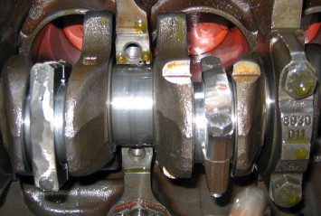

Plate : Crankshaft showing taper wear

### 3.2.3 DESCRIPTION OF THE CRANKSHAFT GRINDING MACHINE

The crankshaft grinding machine is a precision-engineered machine tool designed specifically for restoring worn or damaged crankshaft journals to their correct dimensions and surface finish. It operates on the principle of abrasive material removal, where a rotating grinding wheel trims the journal surfaces to achieve the required undersize and roundness. These machines are built with high rigidity and accuracy to handle the weight, length, and complex geometry of automotive and industrial crankshafts during reconditioning.

In **Afolabi Dinehin and Sons Mechanical Engineering Workshop**, the crankshaft grinding machine consists of a robust bed that supports a rotating headstock and tailstock for securing the crankshaft. A grinding wheel mounted on a powered spindle performs the cutting, while steady rests hold the journals in place to prevent deflection during grinding. The machine also incorporates a coolant system to prevent overheating and ensure a smooth surface finish. Adjustable feed controls allow the operator to set precise material removal rates, ensuring the final journal dimensions meet manufacturer specifications.

Overall, the crankshaft grinding machine is essential for achieving the high level of accuracy required during engine rebuilding, ensuring that reconditioned crankshafts operate reliably and efficiently.

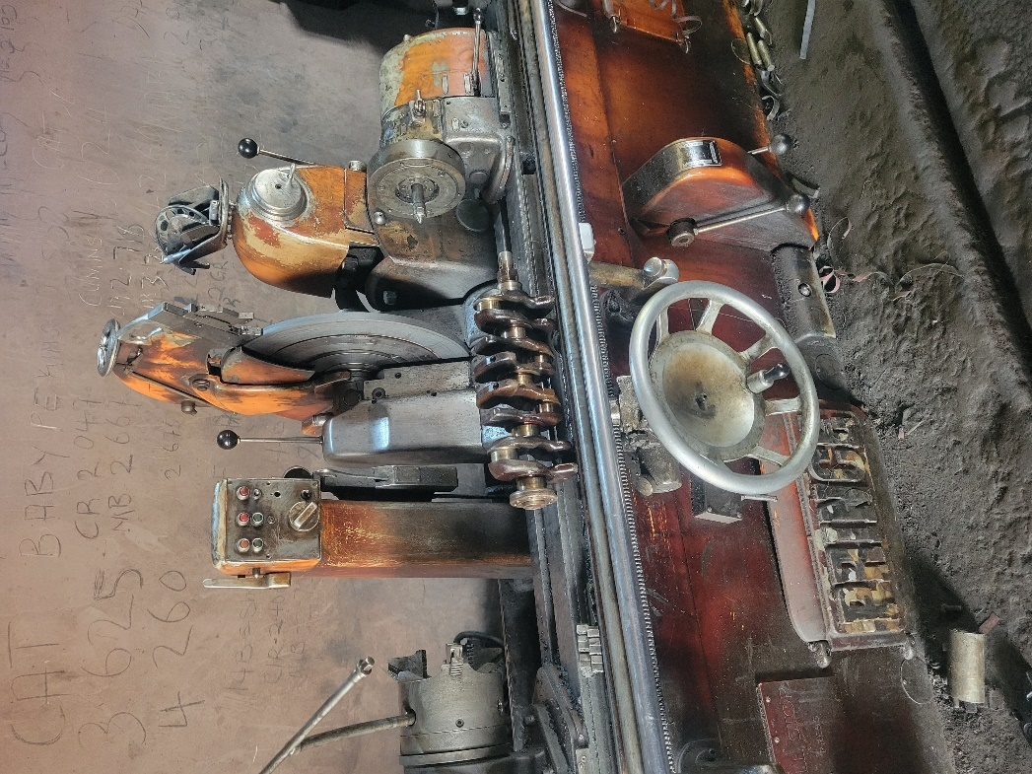

Plate : Crankshaft grinding machine

**Major Components of the Crankshaft Grinding Machine and Their Functions**

The crankshaft grinding machine is made up of several coordinated components, each contributing to accurate journal restoration. A clear understanding of these parts is essential for efficient machine operation and proper maintenance.

1. **Bed / Machine Base**  
   The bed is the main supporting structure of the machine, built from heavy cast iron to provide rigidity and stability. It ensures vibration-free operation during grinding and keeps all components properly aligned.
2. **Headstock**  
   The headstock holds one end of the crankshaft and rotates it during grinding. Its rotational speed can be adjusted to match the grinding requirements. Proper headstock alignment is critical for maintaining journal concentricity.
3. **Tailstock**  
   The tailstock supports the opposite end of the crankshaft. It is adjustable and ensures the crankshaft is firmly held between centers. Correct clamping prevents vibration and ensures even material removal.
4. **Steady Rests**  
   Steady rests support the crankshaft at intermediate points, especially at crankpins, to prevent deflection or bending during grinding. They keep the journals stable and ensure roundness and accurate undersize dimensions.
5. **Grinding Wheel and Wheel Head**  
   The grinding wheel is the abrasive component responsible for removing material from the journals. The wheel head assembly houses the wheel, spindle, and feed mechanisms. It allows for controlled lateral and vertical movement to achieve precise grinding depths.
6. **Work Table / Cross Slide**  
   This component allows the crankshaft to be positioned accurately relative to the grinding wheel. It provides controlled movement along the machine axis, enabling the operator to grind multiple journals sequentially.
7. **Coolant System**  
   A coolant pump and delivery nozzle provide continuous cooling to the grinding area. The coolant prevents overheating, reduces friction, improves surface finish, and prolongs grinding wheel life.

**8. Control Panel / Feed Controls**  
These controls allow the operator to set grinding depth, feed rate, wheel speed, and journal positioning. They ensure consistent, repeatable grinding operations and enhance safety.

### 3.2.4 PRE-GRINDING INSPECTIONS AND MEASUREMENTS

Pre-grinding inspection is a critical step that determines the extent of wear on the crankshaft and the amount of material that must be removed during regrinding. This stage ensures accuracy, prevents unnecessary material loss, and confirms whether the crankshaft is still within serviceable limits before machining begins. All measurements must be conducted on a clean crankshaft, free of oil, carbon deposits, and rust, to avoid inaccurate readings.

1. **Visual Examination**

The inspection begins with a visual check under bright lighting. The technician looks for cracks, surface scoring, burnt journals, oil starvation marks, taper wear, and evidence of previous machining. Cracks around fillets and oil holes are considered critical and may require magnetic particle testing. Journals with deep grooves, metal transfer, or severe discoloration indicate heavy wear and determine the expected undersize cut.

1. **Journal Cleaning and Surface Preparation**

Before measurements, each journal is cleaned using solvent and fine emery cloth to remove carbon and glaze. The oil holes are cleaned using compressed air to remove sludge. Any surface contamination can result in incorrect dimensional readings or mask cracks and scoring. Once cleaned, journals are wiped dry to prepare them for precision measurement tools.

1. **Journal Diameter Measurement (Micrometer Reading)**

A precision outside micrometer is used to measure journal diameter. Each journal is measured in at least **four quadrants** — two vertical and two horizontal positions — to detect taper and out-of-round conditions. Measurements are recorded and compared with manufacturer specifications. If the wear exceeds allowable limits, the journal will be reground to the next standard undersize (typically −0.25 mm, −0.50 mm, or −1.00 mm).

1. **Crankshaft Run-Out Test**

The crankshaft is placed on **V-blocks** and checked with a dial gauge to measure run-out (bending). The dial gauge probe is placed at the center main journal, and the crank is rotated slowly by hand. Any excessive deviation indicates bending. A crankshaft with run-out beyond tolerance may need straightening before grinding or may be rejected entirely, depending on severity.

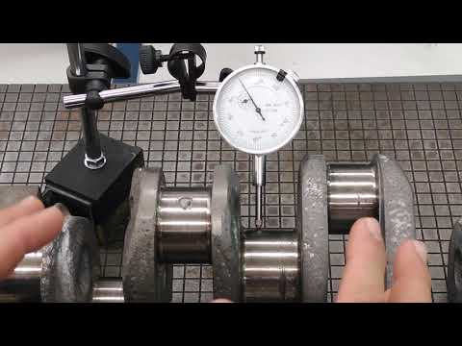

Figure : Dial-gauge setup illustrating crankshaft run-out measurement

### 3.2.5 CRANKSHAFT GRINDING PROCEDURE

Crankshaft grinding is the controlled removal of material from the journal surfaces to restore correct geometry, surface finish, and dimensional accuracy. The procedure must be carried out with precision because even slight deviations can lead to oil starvation, bearing failure, or engine imbalance. Grinding is performed on a specialized crankshaft grinding machine equipped with a rotating abrasive wheel and adjustable chucks for accurate alignment.

1. **Machine Setup and Crankshaft Mounting**

The crankshaft is securely mounted between the machine’s headstock and tailstock centers. Both centers must be clean and properly lubricated to avoid run-out errors. The main journals are used as reference points to align the crankshaft axis with the grinding machine axis. Once aligned, the crankshaft is rotated slowly to verify smooth and true rotation before grinding begins.

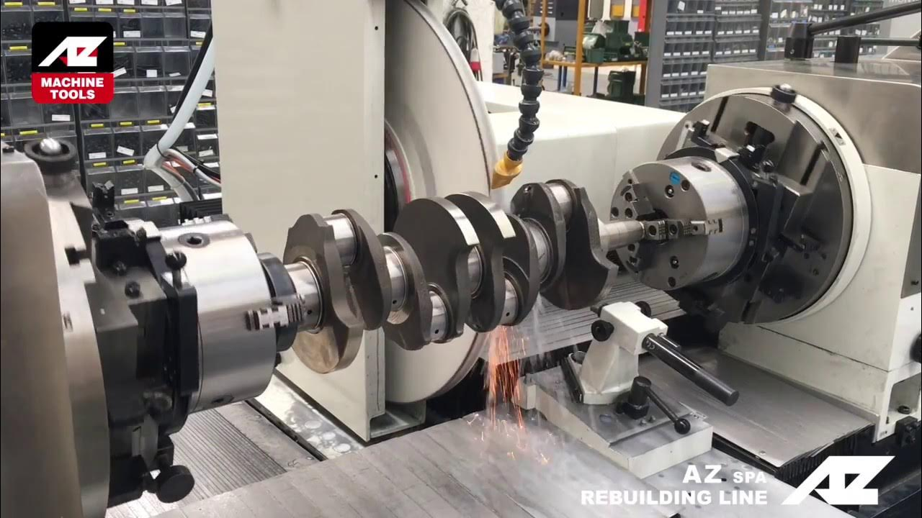

Figure : Setup of crankshaft mounted between headstock and tailstock

*.*

1. **Wheel Dressing and Conditioning**

A diamond-tipped dresser is used to true and shape the grinding wheel before each operation. Dressing ensures the wheel surface is sharp, clean, and correctly profiled for journal radius requirements. This step is crucial, as an improperly dressed wheel can cause chatter marks, incorrect fillet radius, or uneven material removal.

1. **Initial Rough Grinding Pass**

Rough grinding removes the majority of worn material. The wheel is fed into the journal in small, controlled increments while the crankshaft rotates at a set speed. Coolant is continuously applied to dissipate heat and prevent burning of the journal surface. During roughing, the operator focuses on removing damage, correcting taper, and bringing the journal close to the specified undersize diameter.

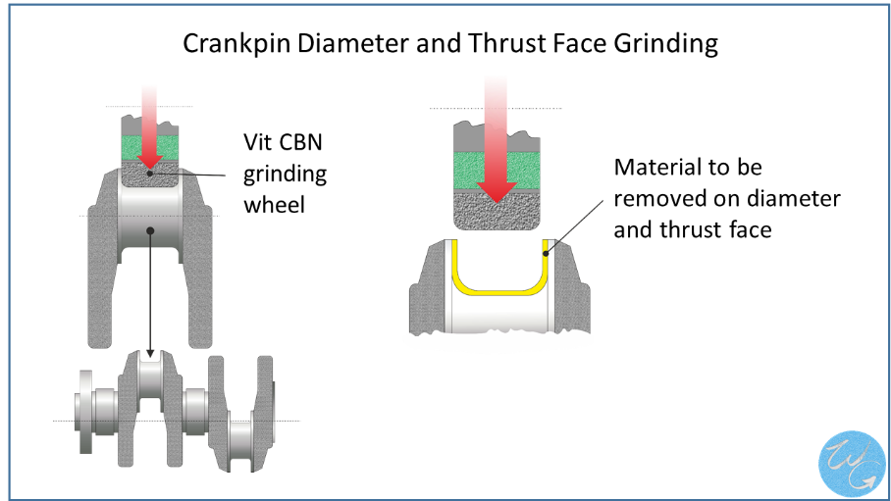

Figure : Grinding procedure

1. **Achieving Correct Fillet Radius**

Each crankshaft journal contains a fillet radius that provides strength and prevents cracking. During grinding, the wheel must match the required radius precisely. Incorrect fillets compromise crankshaft durability. The operator uses a radius gauge to verify accuracy, making adjustments as needed before proceeding to fine grinding.

1. **Fine Grinding Pass**

Once the journal is near the target size, fine grinding is performed using smaller feed increments to achieve the final dimension. The objective is to produce a smooth, even surface finish free of scoring or burns. Frequent micrometer checks are taken to ensure the journal does not undershoot the specified size.

1. **Polishing of Journals**

After grinding, the journal surfaces are polished using a polishing belt or tape while the crankshaft rotates. Polishing removes minute abrasive marks and improves lubrication by producing a mirror-like finish. Proper polishing ensures the crankshaft can operate smoothly with the engine’s bearing shells.

1. **Grinding of All Journals in Sequence**

Grinding is performed systematically — usually starting with the main journals followed by the connecting rod journals. Each journal is completed fully before moving to the next to maintain alignment and avoid cumulative errors. After all journals are ground and polished, the crankshaft is thoroughly cleaned to remove abrasive residue.

1. **Final Dimension and Surface Finish Verification**

Upon completion, the journals are re-measured using micrometers to confirm the final undersize specifications. Surface finish is inspected visually and, when available, with a roughness tester. Journals must be smooth, consistent, and free from chatter marks or burnt spots. A final run-out check is performed before releasing the crankshaft.

### 3.2.6 POST-GRINDING INSPECTION AND QUALITY CHECKS

After completing the grinding operation, the crankshaft undergoes several inspection steps to confirm dimensional accuracy, surface integrity, and alignment. These checks ensure that the crankshaft meets operational standards and will perform reliably under engine loads.

1. **Journal Diameter Verification**

Each journal is measured using an outside micrometer to confirm it matches the specified undersize dimension. Measurements are taken at multiple positions around the journal to detect any taper or out-of-round conditions. The dimension must fall within the recommended tolerance for the corresponding undersize bearing.

1. **Surface Finish Examination**

The ground journals are visually inspected for grinding burns, chatter marks, and surface scratches. A properly finished journal should have a uniform, smooth appearance with no discoloration. When available, a surface roughness tester may be used to verify that the finish meets accepted engine-machining standards.

1. **Fillet Radius Inspection**

The fillet radius at each journal is checked using a radius gauge to ensure it matches the manufacturer’s specifications. An incorrect fillet radius reduces crankshaft fatigue strength and can lead to cracking under cyclic loading, so this inspection step is essential

1. **Run-Out and Alignment Check**

A dial gauge is used to measure crankshaft run-out while the shaft rotates between centers. Excessive run-out indicates bending or misalignment, which must be corrected before installation. This check ensures the crankshaft will rotate smoothly without causing vibration or premature bearing wear

1. **Oil Hole Cleaning and Deburring**

All oil passages are cleaned thoroughly to remove abrasive particles and metal dust generated during grinding. Compressed air and pipe cleaners are typically used. Any burrs around the oil hole edges are removed to promote proper lubrication flow during engine operation.

1. **Final Cleaning and Protection**

The crankshaft is washed, dried, and coated lightly with protective oil to prevent corrosion. At this stage, the crankshaft is ready for reassembly into the engine block or further balancing processes, depending on workshop requirements.

### 3.2.7 SAFETY PRECAUTIONS WHILE PERFORMING CRANKSHAFT GRINDING

Crankshaft grinding involves heavy machinery, rotating components, abrasive wheels, and precision measuring tools. Proper safety precautions are essential to protect the operator and ensure the machine is used correctly. The following practices are standard in professional automotive machine shops.

1. **Proper Personal Protective Equipment (PPE)**

Operators must wear safety goggles or a face shield to protect their eyes from abrasive particles and metal chips. Hearing protection is advised due to the high noise level of the grinder. Safety boots, gloves, and a workshop apron help protect against debris and accidental contact with moving parts.

1. **Secure Clothing and Work Environment**

Loose clothing, jewelry, or long hair must be secured to prevent entanglement in the rotating crankshaft or grinding wheel. The work area around the grinder should be clean, dry, and free of oil spills to avoid slips and accidents.

1. **Correct Wheel Handling and Inspection**

Grinding wheels must be inspected for cracks, chips, or defects before mounting. A ring test is often used to confirm wheel integrity. Wheels must be mounted securely and balanced properly to prevent vibration or catastrophic failure.

1. **Safe Machine Operation**

Before starting the grinder, the operator must confirm that the crankshaft is firmly mounted between the headstock and tailstock centers. All guards and shields must be properly positioned. The grinding wheel should be allowed to reach full speed before contacting the journal surface to avoid shock loading.

1. **Controlled Use of Coolant**

Coolant flow must be steady and well-directed during grinding. Insufficient coolant can cause overheating, burning, and cracking of the journal surface. Operators should avoid placing hands near the coolant stream or rotating components.

1. **Avoiding Excessive Force**

The feed rate must be gradual and controlled. Forcing the wheel into the journal increases the risk of wheel damage, uneven grinding, and machine overload. Precision machining depends on smooth, incremental passes

1. **Awareness of Sparks and Hot Surfaces**

Grinding produces sparks and heat. Operators should avoid placing flammable materials near the machine. Journals may become hot during grinding, so direct contact should be avoided until the crankshaft cools.

1. **Regular Machine Maintenance**

Routine checks for machine alignment, lubrication, wheel condition, and proper operation help prevent accidents caused by malfunction or mechanical failure. Maintenance logs are recommended in busy workshops.

1. **Emergency Preparedness**

Operators should be familiar with the location and use of emergency stops on the machine. Fire extinguishers suitable for electrical and metal fires must be available within reach.

## 3.3 REFRIGERATION SECTION: FABRICATION OF ICE-BLOCK MACHINE

### 3.3.1 INTRODUCTION TO ICE-BLOCK MACHINES

An ice-block machine is a specialized refrigeration unit designed to freeze water into large, solid blocks for commercial use. These machines are widely used across Nigeria for food preservation, cold-chain logistics, hospitality services, and commercial ice sales. Because of the high demand for ice blocks—especially in regions with unreliable power supply—local fabrication has become a practical and cost-effective alternative to imported units. Workshops like Afolabi Dinehin and Sons Mechanical Engineering Workshop play a significant role in meeting this demand by building durable, customizable, and easily serviceable machines.

During my industrial training, I participated directly in the fabrication of a complete ice-block machine from scratch. This included constructing the frame, preparing the condenser and evaporator compartments, installing the compressor and copper line components, setting up electrical controls, insulating the freezing chamber, and testing the unit after assembly. Being involved from the first welding spark to the final cooling test gave me a clear understanding of the engineering principles behind ice production and the practical skills needed to assemble and troubleshoot refrigeration systems.

The fabricated machines generally operate based on the vapor-compression refrigeration cycle, using either a brine cooling system or a direct-freeze setup. Their design typically includes a rigid metal frame, insulated freezing chamber, compressor, condenser, evaporator coil, control panel, refrigerant lines, and other accessories that ensure efficient cooling. The goal is to maintain a stable, low-temperature environment that allows water placed in containers or molds to freeze uniformly into solid ice blocks.

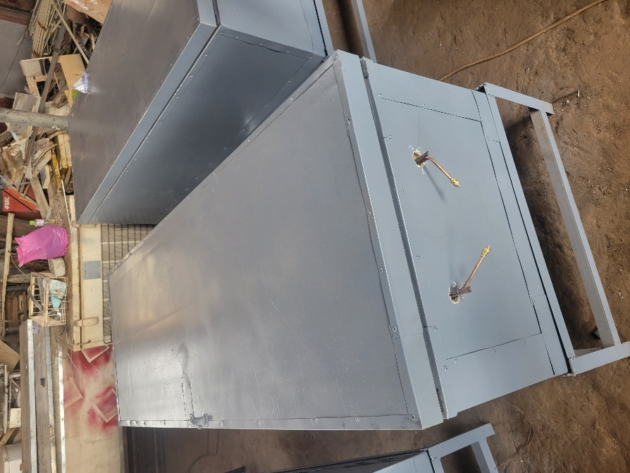 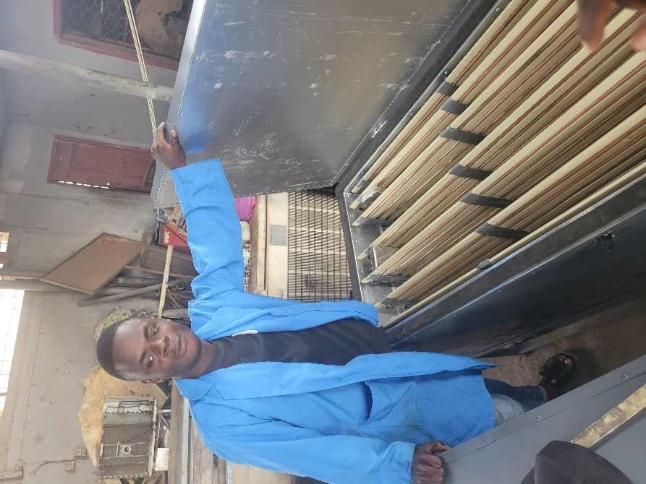

Plate : Outer frame of fabricated Ice-block machine Plate : Fabricated ice-block machine

### 3.3.2 MATERIALS USED IN FABRICATION

The fabrication of an ice-block machine involves a combination of structural, thermal, refrigeration, and electrical materials. Each material is chosen based on its mechanical strength, thermal properties, durability, and compatibility with refrigeration processes. During my training, I worked with or observed the use of the following materials in building a complete unit.

#### 3.3.2.1 STRUCTURAL AND METAL COMPONENTS

The machine’s frame and housing are typically constructed from mild steel due to its strength, weldability, and cost-effectiveness. Angle irons, flat bars, and steel sheets are cut, shaped, and joined to form the frame, compressor stand, and outer panels. Galvanized steel sheets are sometimes used for areas exposed to moisture to reduce corrosion.

#### 3.3.2.2 REFRIGERATION COMPONENTS

These are the core elements responsible for cooling and ice production. They include the compressor, condenser coil, evaporator coil, filter–drier, capillary tube or expansion valve, copper pipes, and service ports. Copper tubing is used extensively because of its excellent thermal conductivity and compatibility with refrigerants. During fabrication, these tubes are cut, flared, bent, and brazed to form sealed refrigerant pathways.

#### 3.3.2.3 INSULATION MATERIALS

Effective insulation is essential for retaining cold air within the ice-block chamber. Expanded polyurethane foam and high-density insulation boards are commonly used. In some locally fabricated versions, Styrofoam sheets or fiberglass are layered within the chamber walls to reduce heat gain. Proper insulation significantly improves freezing speed and reduces compressor workload.

#### 3.3.2.4 ELECTRICAL COMPONENTS AND CONTROLS

The electrical system consists of wires, relays, overload protectors, thermostats, contactors, fan motors, switches, and indicator lights. These components regulate the machine’s temperature, protect the compressor from electrical faults, and ensure safe operation. During fabrication, the control box is assembled and wired according to the circuit layout.

#### 3.3.2.5 CONSUMABLES AND ACCESSORIES

Other materials include welding rods, brazing flux, refrigerant gas (commonly R134a, R404A, or R22 in older systems), cutting discs, paint for corrosion resistance, nuts and bolts, and PVC pipes for drainage. These consumables support the assembly and finishing processes and determine the machine’s durability and appearance.

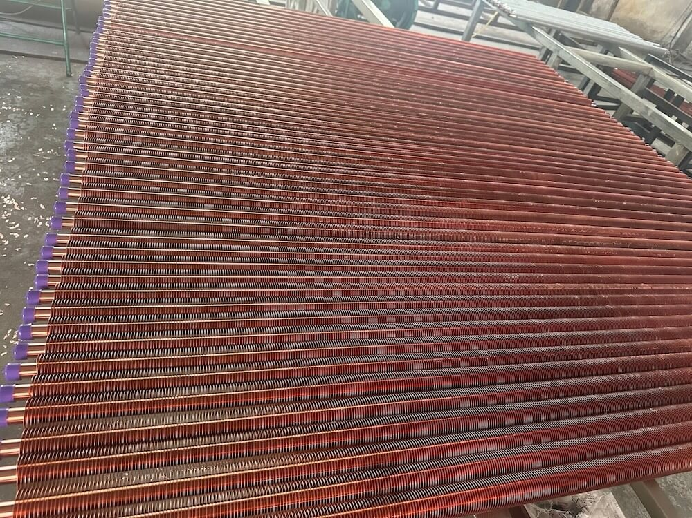

Plate : Evaporator Tubes

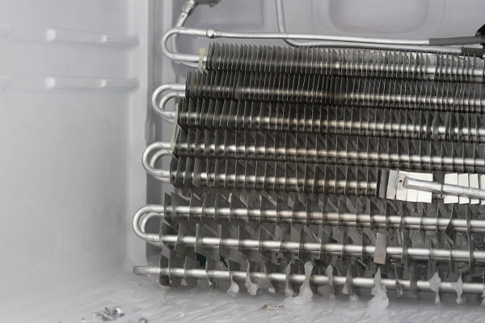 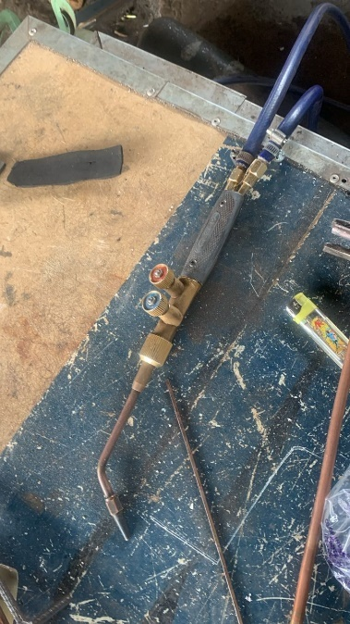

Plate : Condenser coil Plate : Oxy-acetylene gas torch

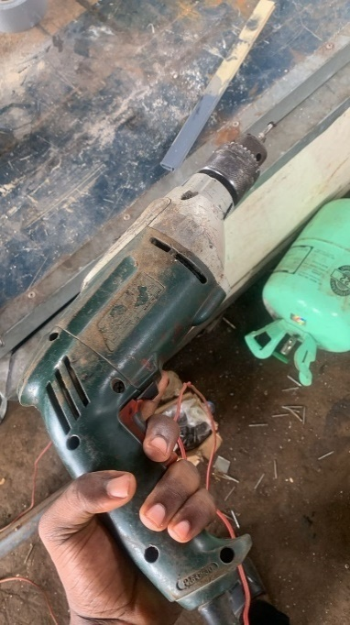 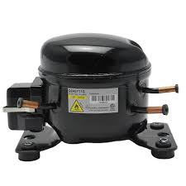

Plate : Rivet Gun Figure : Hermetic Compressor

### 3.3.3. REFRIGERATION CYCLE AND COOLING PRINCIPLES IN ICE‑BLOCK PRODUCTION

The refrigeration unit is the core of any ice‑block machine, and its performance determines how efficiently water converts into solid ice. During my training in the refrigeration and air‑conditioning section, I gained practical experience working with vapor‑compression systems used in locally fabricated ice‑block machines. This section explains the cycle more extensively and highlights the role of each component based on real workshop handling and observations.

#### 3.3.3.1 THE VAPOR‑COMPRESSION REFRIGERATION CYCLE

The vapor‑compression cycle is made up of four main processes: **compression, condensation, expansion, and evaporation**. Each process is essential because the system must continuously absorb heat from the molds and reject it to the surrounding air.

**Compression**

In this stage, low‑pressure refrigerant vapor from the evaporator enters the compressor and is compressed into a high‑pressure, high‑temperature gas. Compression is important because it raises the refrigerant's pressure and boiling point, making it easier to reject heat at the condenser. Without proper compression, the refrigerant cannot circulate or absorb heat effectively, leading to slow or incomplete freezing.

**Condensation**

The hot, high‑pressure gas flows into the condenser. As it releases heat to the surrounding air, it condenses into a high‑pressure liquid. Effective condensation is crucial; if the condenser is dirty, undersized, or poorly ventilated, the gas will not fully condense, causing high pressure, increased power consumption, and longer freezing times.

**Expansion**

The high‑pressure liquid passes through a capillary tube or expansion valve, where its pressure and temperature drop sharply. This expansion process is important because it prepares the refrigerant for heat absorption. If the expansion device is incorrectly sized or partially blocked, the system may starve or flood, both of which significantly impair cooling.

**Evaporation**

The cold, low‑pressure refrigerant enters the evaporator coil and absorbs heat from the water molds (direct freeze) or from the brine solution surrounding them. As it absorbs heat, the refrigerant evaporates back into vapor. Proper evaporation ensures fast, uniform freezing. Any issues such as poor contact, coil blockage, low refrigerant charge, or weak airflow immediately show up as slow ice formation.

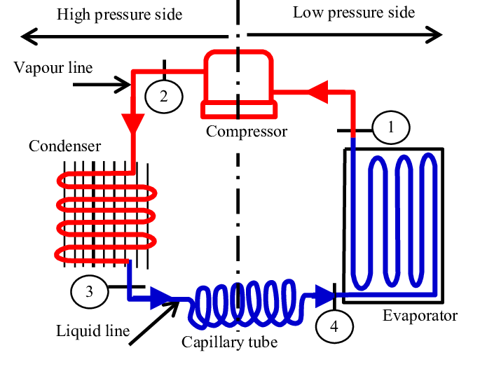

Figure : Vapor-compression cycle diagram

#### 3.3.3.2 KEY REFRIGERATION COMPONENTS AND THEIR ROLES

**Compressor**

The compressor circulates refrigerant throughout the system and maintains the pressure difference between the high and low sides. In the workshop, we mostly worked with 1.5–2 HP hermetic compressors. A good compressor ensures stable suction pressure and consistent cooling. Weak valves, worn pistons, or overheating often result in poor freezing performance.

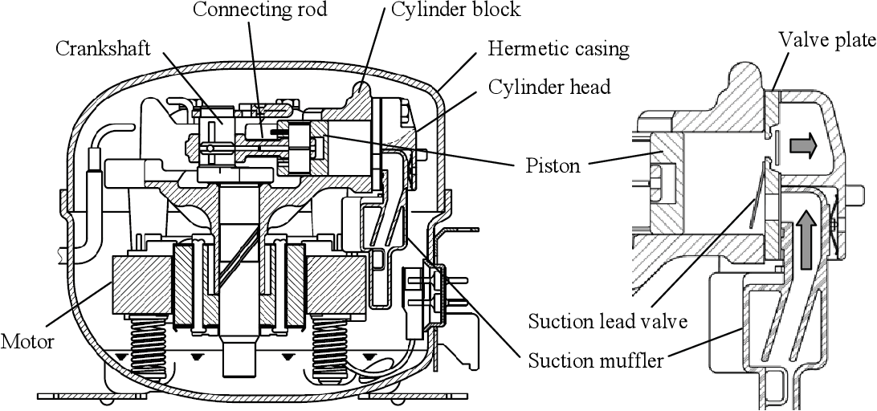

Figure : Labelled diagram showing the internal structure of the hermetic compressor

**Condenser**

The condenser removes heat from the refrigerant and turns it back into a liquid. We typically used air‑cooled condensers made from copper tubes and aluminum fins. Its role is critical because inefficient heat rejection immediately increases system pressure and prolongs freezing time. Condensers must have good airflow and be mounted in open areas to work effectively.

**Metering Device (Capillary Tube / TXV)**

Most locally fabricated machines use capillary tubes due to their simplicity and low cost. They control refrigerant flow into the evaporator while maintaining a pressure drop. Proper capillary tube sizing is essential: too long or too narrow causes starving; too short or too wide causes flooding. Both conditions affect cooling efficiency and compressor life.

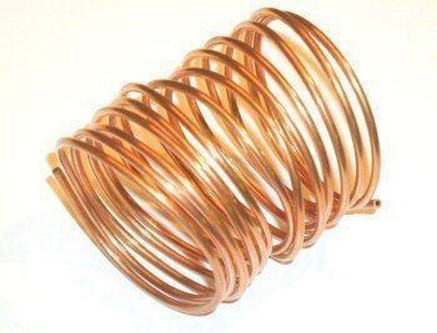

Figure : Capillary Tube

**Evaporator**

The evaporator is where actual heat absorption takes place. Two types are common:

**Brine Tank Evaporator:** Copper tubing submerged in a saltwater mixture. This system provides uniform cooling and is widely used because it is simple to build and very effective for block ice production.

**Direct‑Freeze Evaporator:** Refrigerant lines brazed to metal molds. Faster but expensive and more sensitive to gas charge accuracy.

#### 3.3.3.4 HEAT ABSORPTION IN BRINE OR DIRECT‑FREEZE SYSTEMS

**Brine System**

Saltwater (brine) allows the evaporator to operate below 0°C without freezing. These liquid transfers heat away from the molds uniformly. During fabrication, we ensure the correct brine concentration to reach temperatures between –5°C and –15°C. Brine prevents uneven freezing and helps maintain stable cooling over long periods.

**Direct‑Freeze System**

Heat is absorbed directly from the metal molds, resulting in faster freezing. However, this system requires skilled brazing, excellent refrigerant control, and high‑quality insulation to maintain performance.

**Why Ice‑Block Freezing Takes Long and Requires Stable Cooling**

Ice‑block machines operate for long hours because:

* A block contains a large amount of heat energy that must be removed.
* The latent heat of fusion requires significant energy withdrawal at 0°C.
* Freezing must occur uniformly; rapid or uneven cooling can trap liquid water inside the block.
* The system must maintain stable evaporator temperatures for many hours without fluctuation.

Any interruption—low gas, poor ventilation, overheating condenser, weak compressor—directly delays production.

### 3.3.4 FABRICATION AND ASSEMBLY PROCESS OF THE ICE-BLOCK MACHINE

This stage of the work was where most of the hands-on fabrication took place. At Afolabi Dinehin and Sons Mechanical Engineering Workshop, ice-block machines are built entirely from scratch using locally sourced materials, welding processes, pipe bending, refrigerant line installation, and full electrical wiring. Each step must be done carefully because any error in fabrication can affect cooling performance, freezing time, or long-term reliability.

#### 3.3.4.1 CUTTING AND WELDING OF THE MACHINE FRAME

The fabrication process begins with preparing the main frame. We cut square pipes or angle irons to size using a cutting machine, ensuring all edges are clean to achieve strong weld joints. After measuring and marking, the pipes are tack‑welded to confirm alignment, then fully welded to form a rigid frame. Proper frame welding is important because any misalignment can cause difficulty in mounting the brine tank, compressor, or condenser later.

#### 3.3.4.2 FABRICATION OF THE CONDENSER AND EVAPORATOR HOUSING

The condenser and evaporator compartments are fabricated using metal sheets shaped and folded with a bending machine. These compartments help protect the coils, improve machine rigidity, and ensure proper airflow. We cut sheet metals to the required dimensions, fold where needed, and weld or rivet them to the frame. Openings are also created for fans, ventilation, and maintenance access.

**3.3.4.3 INSTALLATION OF COMPRESSOR AND REFRIGERATION LINE COMPONENTS**

Once the frame and housing are ready, the compressor, condenser, capillary tube, filter drier, and evaporator coil are installed. At the workshop, we used brazing torches to connect copper tubes, ensuring airtight joints. Care is taken to avoid moisture entering the lines, as this can cause blockages. We also mount vibration pads under the compressor to reduce noise and wear.

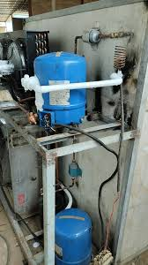

Plate : Installation of the compressor and refrigerant lines

#### 3.3.4.4 ELECTRICAL WIRING AND CONTROL SYSTEM SETUP

After mechanical installation, the electrical components are wired. These include the thermostat, overload protector, relay, contactor, fan motors, and control switches. During training, we ensured all wiring was properly insulated and routed neatly to avoid short circuits. The control system ensures the compressor cycles correctly and prevents overheating or pressure buildup.

#### 3.3.4.5 INSULATION AND FINAL ASSEMBLY

Good insulation is essential for maintaining low temperatures. We used polyurethane foam, Styrofoam, or fiber insulation around the tank and evaporator housing to minimize heat gain. After insulation, the outer panels are attached, usually with screws or spot welding. Final assembly includes sealing edges, checking for gaps, and confirming that the tank sits correctly within the frame.

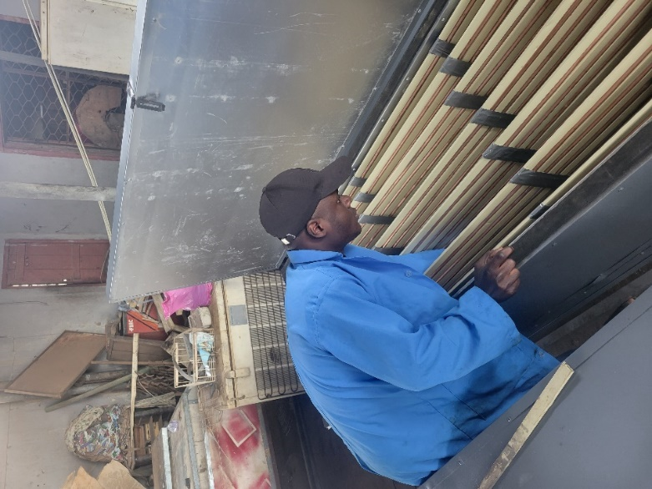

Plate : Final assembly/Quality assurance operations

#### 3.3.4.6 TESTING AND QUALITY CONTROL

Before the machine is put into service, it undergoes a series of tests. We pressure-test the refrigerant lines using nitrogen to check for leaks, then vacuum the system to remove moisture. Once confirmed, refrigerant is charged based on the compressor specifications. The machine is run under observation to check for stable suction pressure, proper temperature drop, and uniform freezing.

Testing also includes checking electrical safety, thermostat function, fan operation, and overall vibration levels.

### 3.3.5 COMMON FAULTS IN ICE-BLOCK MACHINES AND THEIR CAUSES

During my training, I observed that ice-block machines frequently experience certain faults due to continuous operation, environmental conditions, or component wear. Understanding these issues and their underlying causes is essential for proper maintenance, troubleshooting, and ensuring consistent freezing performance.

**1. Poor Freezing or Slow Freezing**

This is one of the most common issues encountered in workshop-built ice-block machines. Poor freezing often results from inadequate heat removal within the evaporator chamber. Contributing factors include low refrigerant charge, dirty condenser coils, weak compressor performance, or poor insulation. When insulation becomes compromised, external heat enters the freezing chamber and increases the load on the refrigerating system, slowing freezing time significantly. Water quality and the thickness of ice molds used can also influence freezing duration.

**2. Compressor Issues**

Compressor-related faults usually manifest as hard starting, abnormal noise, overheating, or complete failure to run. Common causes include electrical relay faults, worn piston rings (in older compressors), low lubrication, and high discharge pressure caused by blocked condensers. A failing compressor directly affects the cooling cycle, reducing its ability to compress refrigerant vapor effectively and resulting in poor cooling performance.

**3. Gas Leakage**

Refrigerant leakage is another frequent problem in fabricated ice-block machines. This typically occurs at brazed joints, capillary tube connections, or compressor discharge lines. Leaks cause the refrigerant charge to drop, leading to low evaporator pressure and insufficient cooling. In many cases, vibration from the compressor or poor brazing techniques during assembly are responsible. Detecting and fixing leaks early prevents compressor strain and extends system lifespan.

**4. Electrical Faults**

Electrical issues range from wiring insulation breakdown to faulty relays, blown fuses, or thermostat malfunction. Because the machine runs for long hours, poor electrical connections can result in intermittent operation or complete system shutdown. Faulty overload protectors may also trip frequently, preventing the compressor from functioning. Ensuring proper wiring practices and clean contact points helps reduce these issues.

**5. Fan and Airflow Problems**

A condenser fan that fails to operate or rotates slowly will cause the condenser to retain heat, resulting in high discharge pressure and reduced system efficiency. Dust accumulation on the fan blades or worn fan motor bearings are common causes. Poor airflow around the condenser compartment—such as placing the machine too close to a wall—also affects cooling performance. Adequate ventilation is essential for maintaining optimum heat rejection.

**6. Thermostat or Relay Failure**

Faulty thermostats or relays disrupt the compressor's control cycle. A thermostat stuck in the "off" position prevents the compressor from running, while a defective relay can stop the compressor from starting altogether. Relay failures are often due to electrical surges or prolonged cycling. These components must always be tested first during troubleshooting because they directly control the machine’s cooling operation.

### 3.3.6 PREVENTIVE MAINTENANCE PRACTICES FOR ICE-BLOCK MACHINES

**1. Routine Cleaning**  
Regular cleaning prevents dirt, algae, and mineral buildup that can insulate heat-transfer surfaces or obstruct airflow. The evaporator, condenser fins, water tanks, and brine reservoirs should be cleaned at consistent intervals. Clean equipment ensures efficient heat exchange and reduces compressor load.

**2. Lubrication of Mechanical Components**  
Fan motors, bearings, and moving linkages require periodic lubrication to minimize friction and prevent overheating. Proper lubrication improves mechanical efficiency and extends the service life of rotating components.

**3. Scheduled Inspections**  
Routine checks help detect faults before they escalate. Inspect wiring, pipe joints, system insulation, and mounting hardware. Look for signs of wear, corrosion, vibration, or unusual noise that may indicate developing issues.

**4. Checking Electrical Systems**  
Inspect contactors, relays, thermostats, capacitors, and wiring for signs of damage or overheating. Poor electrical connections can lead to short cycling, reduced cooling performance, or complete system failure.

**5. Monitoring Refrigerant Pressure**  
Both suction and discharge pressures should be monitored to ensure the refrigerant circuit is operating within design limits. Abnormal readings may indicate leakage, partial blockage, moisture contamination, or compressor issues.

**6. Ensuring Proper Insulation and Water Handling**  
Damaged insulation increases heat gain and slows freezing time. Ensure all insulation around the evaporator, brine tank, and refrigerant lines is intact and moisture-free. Also maintain proper water quality and ensure tanks remain free of contaminants or debris that could affect freezing efficiency.

### 3.3.7 REPAIR TECHNIQUES FOR REFRIGERANT LEAKAGE

Refrigerant leakage is one of the most common and performance‑destroying faults in ice‑block machines. Because the system relies on a sealed vapor‑compression loop, even minor leaks can severely reduce cooling capacity, extend freezing time, and overload the compressor. This section presents the complete workshop‑level procedure for identifying, sealing, testing, and recharging leaking refrigeration systems.

**1. Leak Detection Techniques**

Effective repair begins with locating the source of the leak. Workshop‑friendly methods include:

1. **Soap‑Solution Method**  
   A simple, reliable technique used in most local fabrication shops. After pressurizing the system with dry nitrogen, a soap solution is applied to joints and brazed areas. Bubble formation indicates a leak point.
2. **Electronic Leak Detector**  
   More accurate and used in advanced workshops. The detector senses refrigerant molecules escaping from the system, making it easier to find tiny leaks around inaccessible areas.
3. **Ultraviolet (UV) Dye Method**  
   A UV‑reactive dye is added to the system. Once the refrigerant escapes, the dye stains the leaking spot. A UV lamp is then used to trace it.

**2. Brazing and Sealing Techniques**

After identifying the leak, proper sealing is crucial to prevent recurrence.

1. **Surface Preparation**  
   The affected copper or aluminum section is cleaned thoroughly using emery cloth. Removing oil and oxide ensures the brazing filler bonds properly.
2. **Applying Brazing Heat**  
   An oxy‑acetylene or MAP‑gas torch is used to heat the area. Even heating prevents pinholes and ensures the filler flows smoothly.
3. **Introducing Brazing Rod/Filler**  
   Silver‑based brazing rods (commonly 15% silver) are preferred for refrigeration lines because they produce strong, leak‑proof joints.
4. **Cooling and Inspection**  
   After brazing, the joint is allowed to cool naturally. Rapid quenching is avoided to prevent cracking.

A quick visual inspection helps confirm uniform filler distribution.

**3. Flushing and Pressure Testing**

Before recharging, the system must be cleaned and tested to confirm the repair.

1. **Flushing the System**  
   Moisture, sludge, and debris are removed using:
   * Dry nitrogen blowout
   * Refrigeration flushing chemicals (where available)

This step protects the compressor and ensures unrestricted refrigerant flow.

1. **Pressure Testing**  
   The system is pressurized with dry nitrogen—typically between 150–200 psi depending on the refrigerant type.

The pressure is monitored for 20–30 minutes. Any pressure drop indicates a remaining leak.

**4. System Evacuation and Recharge**

Once confirmed leak‑free, the machine is prepared for operation.

1. **Vacuum Evacuation**  
   A vacuum pump is connected and run until the system reaches at least **500 microns**. This removes:
   * Moisture
   * Air
   * Non‑condensable gases

Moisture inside the system can freeze and block the capillary tube, causing poor freezing performance.

1. **Refrigerant Charging**  
   Charging is done using a manifold gauge set, following the manufacturer’s recommended charge weight or pressure range.

For ice‑block machines using R134a or R22, the goal is to achieve:

* + Stable suction pressure
  + Frost formation at the evaporator
  + Normal condenser temperature

1. **Final Operational Test**  
   The machine is run for 20–30 minutes while monitoring:
   * Compressor sound
   * Suction line temperature
   * Frost development
   * Ampere draw

Any anomalies indicate further system checks are needed.

**Recommended Image Placements**

* Leak testing using a soap‑solution spray.
* Brazing a copper refrigeration line.
* Vacuum pump and manifold gauge setup.

### 3.3.8 SAFETY MEASURES DURING REPAIR AND MAINTENANCE

Safety is a critical aspect of working on ice-block machines, especially because the systems involve electrical components, pressurized refrigerants, welding operations, and rotating mechanical parts. During my training, safety protocols were always emphasized to prevent injuries, equipment damage, and avoidable hazards. The following measures outline the essential precautions followed in the workshop.

**1. Gas Handling Safety**:  
Refrigerants operate under high pressure, and careless handling can lead to frostbite, asphyxiation, or equipment damage. Before opening any part of the system, we ensured the machine was disconnected and pressure was released safely. Leak detection was done in a controlled manner using soapy water or an electronic detector, never with open flames. Cylinders were stored upright in well-ventilated areas and handled with appropriate valves and gauges.

**2. Electrical Safety**:  
Ice-block machines rely heavily on electrical components such as compressors, relays, thermostats, and fan motors. During repairs, we always isolated the power supply before touching any wiring. Proper insulated tools were used, and connections were tightened firmly to prevent arcing. Faulty wires, burnt terminals, or loose connectors were replaced immediately to avoid short circuits and shocks.

**3. Welding Safety**:  
Fabrication and repair often involved welding, especially when sealing refrigerant line leaks or constructing machine frames. We used welding goggles, gloves, and aprons to protect against sparks and UV radiation. The area was cleared of flammable materials, and fire extinguishers were kept nearby. We also allowed the metal to cool properly before handling to avoid burns.

**4. Heat and Pressure Precautions**:  
The refrigeration system can build significant pressure during operation. Before brazing or cutting pipes, we confirmed the system was completely depressurized. The compressor was allowed to cool before servicing, as internal heat and pressure can pose risks. When charging refrigerant, we monitored gauges closely to avoid overcharging and pressure spikes.

**5. PPE and Safe Workshop Practices**:  
Throughout the fabrication and repair processes, we relied on personal protective equipment such as gloves, boots, safety goggles, and overalls. The workshop was kept organized to prevent tripping hazards. Proper communication among team members was maintained during lifting heavy components like compressors or frames. Good ventilation was also essential, especially when working with chemicals, refrigerants, or welding fumes.

This structured approach ensured safe, efficient work throughout the fabrication, repair, and maintenance of ice-block machines.

## 3.4 ENGINE BLOCK BORING AND REBORING SECTION

### 3.4.1 INTRODUCTION TO CYLINDER BORING AND REBORING

Cylinder boring and reboring are essential engine reconditioning processes used to restore worn or damaged cylinder walls to their proper dimensions. Over time, engine cylinders develop wear due to high temperatures, friction, lubrication failure, and continuous piston movement. This wear often results in scoring, taper, and out-of-round conditions, which reduce engine efficiency and compression. When these defects exceed manufacturer tolerances, boring or reboring becomes necessary to return the cylinder to a uniform and functional geometry.

In the workshop, cylinder boring involves enlarging the cylinder to the next suitable oversize using a precision boring machine. Reboring, on the other hand, refers to cutting the bore beyond its original size to eliminate deep wear marks or damage, after which an oversized piston and rings are installed. In some cases, sleeving is required, especially when the bore damage is excessive, the cylinder is already at its final oversize, or when cracks are detected. Sleeving allows the cylinder to be restored to its standard size using a pressed-in liner.

Honing typically follows the boring process. It creates the characteristic cross-hatch pattern on the cylinder surface, which improves lubrication retention and ensures proper piston ring seating. This final surface finish is crucial for achieving optimal compression and reducing oil consumption.

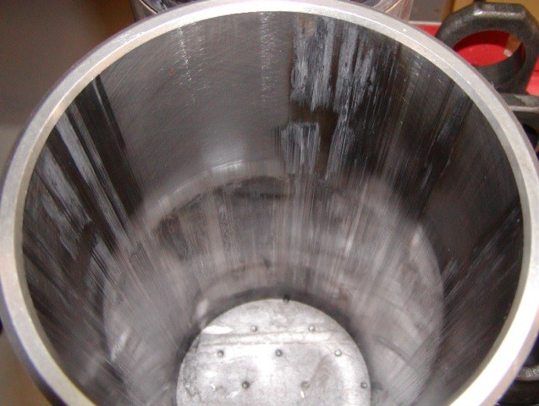 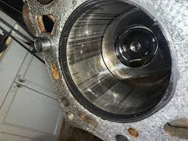

Plate : Cylinder surface showing discoloration

and wear due to heat Plate : Cylinder surface showing wear marks

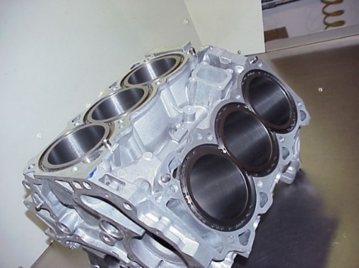

Plate : Engine block with sleeved cylinder configuration

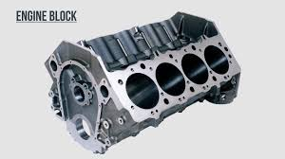

Plate : Engine block with standard cylinder configuration

### 3.4.2 MATERIALS AND TOOLS USED IN CYLINDER BORING AND REBORING

Cylinder boring and reboring require durable materials and precision tools to achieve accurate and repeatable results. During my training, I worked directly with these tools and components while observing the specific requirements for machining cast iron and aluminum engine blocks.

1. **Materials Worked On**

* **Cast Iron Engine Blocks:** Most conventional engines brought to the workshop were cast iron. They are easy to machine, stable under heat, and provide a smooth final finish when honed.
* **Aluminum Engine Blocks:** Increasingly common in modern vehicles. These often contain cast-iron sleeves, which are removed or replaced during major repairs.
* **Dry and Wet Cylinder Liners (Sleeves):** Used for sleeving operations when the bore is excessively worn or cracked.

1. **Key Tools and Equipment**

* **Cylinder Boring Machine:** A vertical or horizontal precision machine used to enlarge cylinder bores to exact oversize. This machine allows fine feed control and alignment.

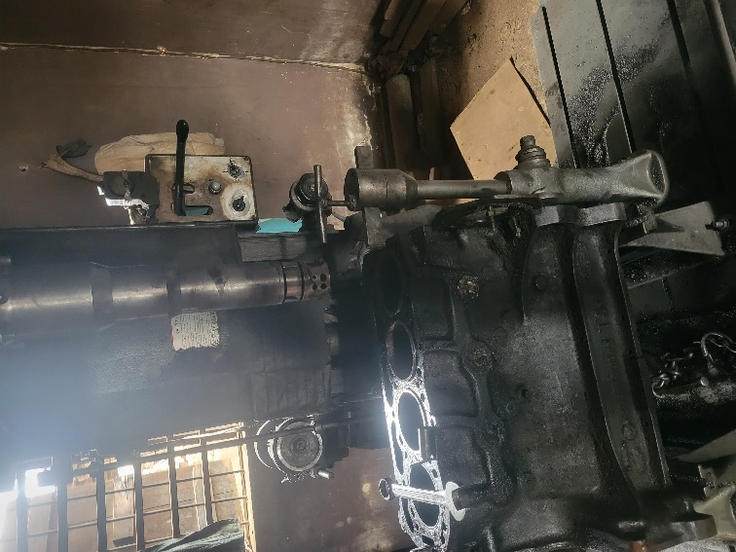

Plate : Vertical Boring machine

* **Dial Bore Gauge:** For checking bore diameter, taper, and out-of-roundness before and after machining.
* **Inside Micrometer / Telescopic Gauge:** Used to measure internal diameters with high accuracy.
* **Outside Micrometer:** For measuring pistons, sleeves, and other components that determine the target bore size.
* **Honing Machine or Honing Tool:** Used after boring to achieve the final smooth cross-hatch finish.
* **Surface Plate and Straight Edge:** To inspect block flatness and ensure proper alignment.
* **Precision Vernier Caliper:** For general measurements around the block and pistons.
* **Boring Bars and Cutting Tools:** Replaceable tool bits made of carbide or high-speed steel.
* **Cooling and Lubricating Fluids:** Used to prolong tool life, reduce heat, and maintain surface quality.

1. **Safety and Handling Materials**

* **Cutting Oils and Coolants:** Reduce friction and prevent overheating of tools and the block.
* **Cleaning Agents:** Kerosene or degreasing solutions used for preparing the block before machining.
* **Protective Shims and Clamps:** Ensure the block is well-secured in the machine without distortion.

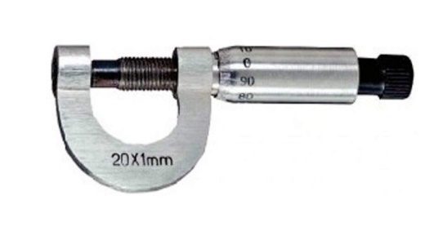 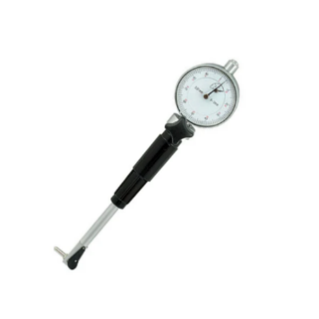

Figure : Micrometer screw gauge Figure : Dial Bore Guage

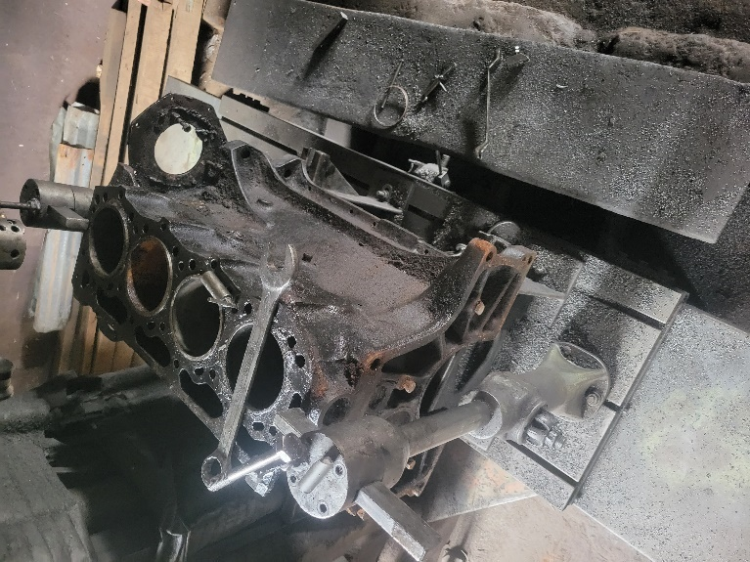 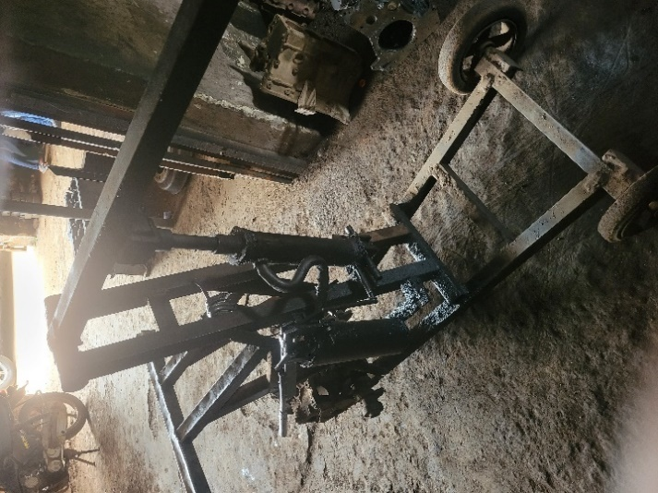

Plate 18: Engine block setup on machine bed Plate : Engine Crane/Lift

### 3.4.3 MEASUREMENT STANDARDS AND TOLERANCES

**1. Standard Cylinder Dimensions**

* Nominal bore size as specified by manufacturer (e.g., 70mm, 82mm, 93mm).
* OEM tolerances: ±0.01–0.03 mm depending on engine class.
* Roundness tolerance: typically within 0.01–0.02 mm.
* Cylindricity tolerance: 0.01–0.03 mm.

**2. Wear Evaluation**

* Measure at top, middle, and bottom of bore (X and Y axes).
* Record taper: allowable limit usually 0.02–0.05 mm.
* Record out-of-round: allowable limit usually 0.01–0.03 mm.
* Compare against service manual thresholds.

**3. Honing Pattern Requirements**

* Crosshatch angle: 35°–45° for most gasoline/diesel engines.
* Surface roughness (Ra): 0.2–0.6 µm depending on ring type.
* Plateau finish recommended for modern low-friction rings.

**4. Oversize and Sleeving Specifications**

* Typical oversize increments: +0.25 mm, +0.50 mm, +1.00 mm.
* Sleeving interference fit: 0.05–0.10 mm depending on material.
* Final bore after sleeving must be honed to OEM finish spec.

### 3.4.4 PRE-BORING INSPECTION AND MEASUREMENTS

A detailed pre-inspection is mandatory before any boring or reboring operation. This stage determines whether a cylinder block is within serviceable limits, requires oversize boring, or must be sleeved. Accurate measurement at this point prevents machining errors and ensures correct piston-to-wall clearances.

1. **Visual Inspection**

* Check for **scoring**, **deep scratches**, and **abrasion marks** caused by ring wear or contamination.
* Identify **ridge formation** at the top of the cylinder where rings stop during operation.
* Look for **heat marks**, **discoloration**, or **cracks** resulting from overheating or lubrication failure.
* Examine for **corrosion pitting**, common in engines exposed to moisture.

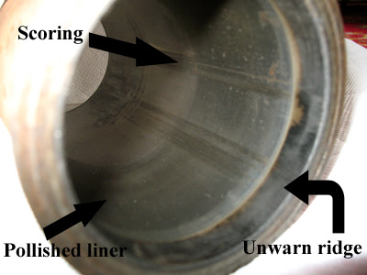 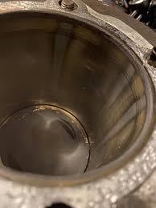

Figure : Engine cylinder showing scoring defects Plate : Engine cylinder showing corrosion pitting

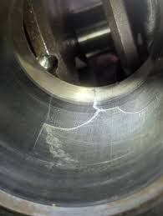 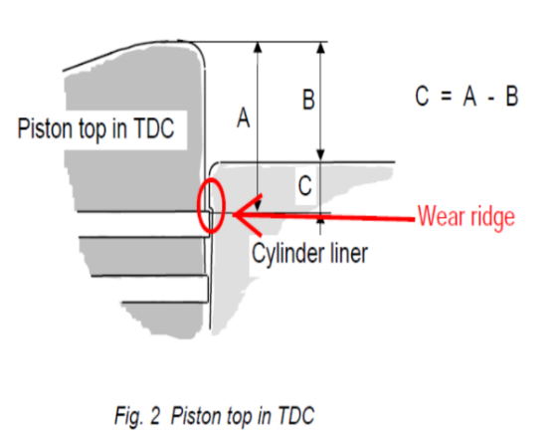

Plate : Cylinder inner surface showing cracks Figure : Illustration of ridge wear on piston top

1. **Cleaning and Preparation**

* Degrease the block using solvent or steam cleaning.
* Remove carbon deposits using a ridge reamer (if applicable).
* Ensure coolant jackets and oil passages are flushed before measurement.

1. **Dimensional Measurement:** Use precision tools to assess the current condition of the bore:

* **Inside micrometer or bore gauge** for diameter checks.
* **Dial gauge** for straightness verification.
* **Feeler gauges** where applicable.

Measurements must be taken at:

1. **Top**, **middle**, and **bottom** of the cylinder.
2. **Two axes**—front–back and left–right.

This reveals:

* **Taper** (difference between top and bottom).
* **Out-of-round/ovality** (difference between axes).
* **Wear concentration zones**.

1. **Service Limits and Oversize Classification** Compare findings with manufacturer specifications:

* Maximum allowable **taper**.
* Maximum **out-of-round**.
* Recommended **oversize piston classes** (e.g., +0.25 mm, +0.50 mm, +1.00 mm).

**If the wear exceeds limits but is below maximum reboring allowance, oversize boring is performed. If wear or cracking is excessive, sleeving is required**.

1. **Decision Criteria Before Machining**

* Proceed with boring if the cylinder can safely be enlarged to the next oversize.
* Proceed with sleeving if cracks, deep scoring, or over-wear make boring insufficient.
* Reject the block if structural integrity is compromised.

**5. Final Machining and Finishing:**

**I. Finish bore:** Machine the inner surface of the sleeve to achieve the desired surface finish and dimensional accuracy.

**II. Honing**: Use honing stones or abrasive brushes to impart a precise cross-hatch pattern on the sleeve surface, promoting proper lubrication and piston ring seating.

**6. Assembly and Testing:**

**I. Reassembly:** Reassemble the engine components, including pistons, piston rings, connecting rods, and cylinder head, following manufacturer specifications.

**II. Testing:** Conduct a compression test and leak-down test to verify proper cylinder sealing and engine performance before returning the engine to service.

### 3.4.5 CYLINDER BORING PROCEDURE

The cylinder boring operation is the core machining process in engine reconditioning. It eliminates wear, restores geometric accuracy, and prepares the cylinder for oversize pistons or sleeve installation. This section covers both standard reboring (without sleeving) and reboring with sleeve installation, as both methods were observed and practiced during the industrial attachment.

**A. REBORING OPERATION (WITHOUT SLEEVING)**

This procedure is used when cylinder wear is within acceptable limits and can be corrected by machining to the next oversize piston class.

**1. Preparation**

**i. Securing the Engine Block**

The engine block must be firmly mounted to prevent movement during machining. The block was positioned on the boring machine bed with cylinders oriented vertically for easier access and chip evacuation.

* Clamping was done using T-bolts and step blocks, ensuring the block was held rigidly without causing distortion to thin-walled sections.
* Care was taken not to overtighten clamps near cylinder walls, as this can induce stress and affect bore geometry.

**ii. Final Inspection Before Machining**

Although detailed inspection was covered in the previous section, a final check was performed:

* Visual confirmation of cylinder condition
* Verification that all measurements were recorded
* Ensuring coolant passages were clear and the block was completely clean

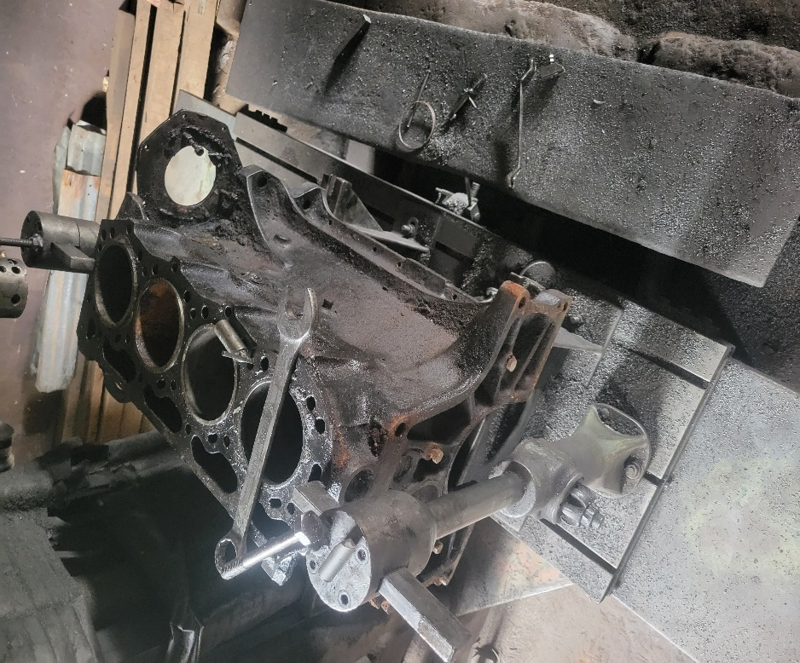

Plate : Engine block mounted and clamped on vertical boring machine bed

**2. Machine Setup and Alignment**

**i. Centering the Boring Bar**

Accurate centering is critical to ensure the new bore remains concentric with the crankshaft centerline.

* The boring bar was positioned approximately at the cylinder center
* A dial indicator was mounted on the spindle and swept around the bore interior
* The machine table was adjusted until runout was minimized to within 0.02 mm
* Some operations used the main bearing bores as reference points to maintain factory alignment

Misalignment at this stage results in offset bores, causing piston slap, uneven ring wear, and excessive oil consumption.

**ii. Tool Selection and Installation**

* **Boring bar:** A rigid carbide-tipped boring bar was selected for cast iron blocks. The rigidity prevents deflection during cutting.
* **Cutting insert:** Sharp inserts were installed and indexed properly. Dull or damaged tools generate excessive heat and poor surface finish.
* **Tool height adjustment:** The cutting edge was set at spindle centerline height to avoid producing tapered bores.

**3. Initial Boring (Roughing Pass)**

The roughing operation removes the bulk of worn material, bringing the cylinder close to final diameter.

**i. Cutting Parameters**

* **Depth of cut:** 0.25–0.50 mm per pass, depending on the amount of material to be removed and machine capacity
* **Feed rate:** 0.1–0.2 mm per revolution for balanced material removal
* **Cutting speed:**
  + Cast iron blocks: 50–80 m/min
  + Aluminum blocks: 150–250 m/min
* **Coolant:** Continuous flood cooling with soluble oil mixture to remove chips, control heat, and extend tool life

**ii. Process Monitoring**

During roughing, several observations were made:

* Listening for chatter or unusual vibration, which indicates tool deflection or inadequate clamping
* Checking chip formation—long, curled chips in aluminum suggest proper cutting conditions; fine, powdery chips are normal for cast iron
* Periodically stopping to verify bore diameter with inside micrometers to avoid overcutting

**4. Finishing Passes**

The finishing operation achieves the target oversize diameter with high precision and acceptable surface finish.

**i. Final Cutting Parameters**

* **Depth of cut:** 0.05–0.15 mm (light cuts for dimensional accuracy)
* **Feed rate:** Reduced to 0.05–0.10 mm/rev for finer surface finish
* **Target dimension:** The bore was machined to approximately 0.05–0.10 mm below final size to allow material for the subsequent honing operation

**Example:** For a standard bore of 86.00 mm being rebored to +0.50 mm oversize:

* Target final diameter = 86.50 mm
* Boring finish target = 86.40–86.45 mm
* Remaining material for honing = 0.05–0.10 mm

**ii. Surface Finish Control**

The finish pass aimed for a surface roughness that would accept honing stones properly. Too rough a finish makes honing difficult; too smooth prevents proper stone cutting action.

**5. In-Process and Final Measurement**

Dimensional verification was performed at multiple stages:

**i. During Roughing**

* Bore diameter checked every 2–3 passes to monitor material removal rate

**ii. After Finishing**

* Measurements taken at three levels (top, middle, bottom) in two perpendicular axes
* Instruments used: inside micrometers and dial bore gauges
* **Acceptable tolerances:**
  + Diameter accuracy: ±0.02 mm from target
  + Taper: less than 0.01 mm
  + Out-of-round: less than 0.01 mm

All measurements were recorded on inspection sheets for each cylinder.

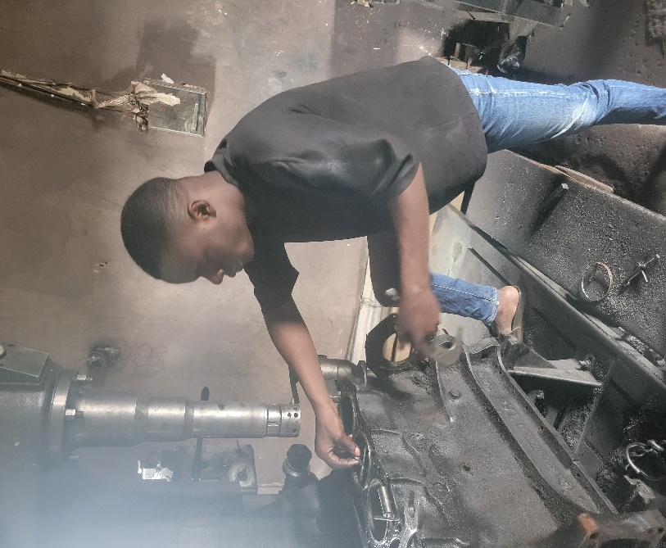

Plate : Using bore gauge to verify finished cylinder diameter

**6. Common Problems and Corrections**

During the attachment, several machining challenges were encountered and resolved:

Table : Common Boring Problems and Corrections

| **Problem** | **Cause** | **Correction Applied** |
| --- | --- | --- |
| Chatter marks on bore surface | Excessive spindle speed, insufficient rigidity | Reduced RPM, verified clamping tightness |
| Bore taper | Unlevel block mounting, tool deflection | Re-leveled block, used more rigid boring bar |
| Overcut beyond target size | Inattentive measurement | Prevention through frequent measurement; overcut cylinders required sleeving |
| Poor surface finish | Dull cutting tool, inadequate coolant | Replaced insert, increased coolant flow |

**7. Cleaning and Deburring**

After boring, cylinders required thorough cleaning before honing:

* Bores were wiped with clean rags soaked in solvent to remove metal particles and coolant residue
* Sharp edges at the top of the bore (deck surface intersection) were deburred using fine emery cloth or a hand scraper
* Final cleaning with compressed air to remove any remaining debris

**B. REBORING OPERATION (WITH SLEEVING)**

Sleeving, also called cylinder re-sleeving, is necessary when cylinder wear exceeds the maximum reboring limit, or when cracks, deep scoring, or corrosion damage make standard reboring insufficient. A sleeve (cylinder liner) is installed to create a new, machinable surface.

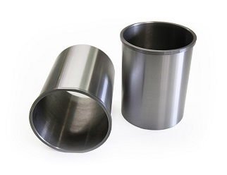 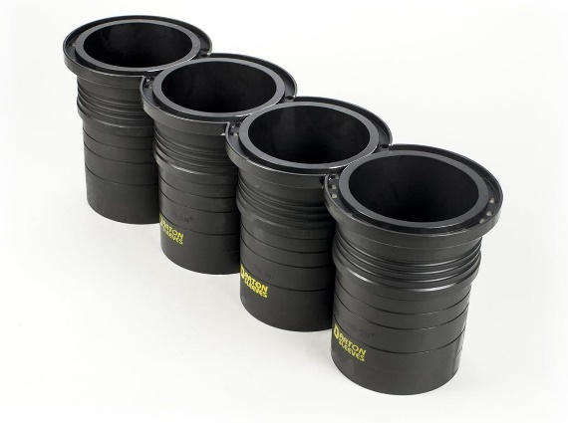

Figure : Dry Cylinder Sleeves Figure : Wet Cylinder sleeves

**1. Assessment and Sleeve Selection**

**i. Determining Need for Sleeving**

Sleeving was required when:

* Cylinder wear exceeded manufacturer's maximum oversize specification
* Cracks were present in the cylinder wall
* Deep scoring from piston or ring failure could not be removed by boring
* Previous reboring had already used maximum oversize

**ii. Sleeve Type Selection**

Two types of sleeves were used during the attachment:

* **Dry sleeves:** Do not contact coolant; supported by the block over their entire length. Used in most gasoline engines.
* **Wet sleeves:** Contact coolant directly; sealed at top and bottom with O-rings. Common in diesel engines and some high-performance applications.

**iii. Sleeve Material and Sizing**

* Material: Cast iron sleeves for cast iron blocks; sometimes ductile iron for increased strength
* Sizing: Sleeves were ordered with outer diameter matching the bored cylinder and inner diameter suitable for standard or first oversize pistons

**2. Cylinder Preparation for Sleeve Installation**

**i. Boring the Cylinder for Sleeve Fit**

The worn cylinder had to be bored to a larger diameter to accept the sleeve's outer diameter.

* **Boring setup:** Similar to standard reboring—block clamped, boring bar centered
* **Target diameter:** Machined to provide proper interference fit (typically 0.05–0.15 mm interference for press-fit sleeves)
* **Counterboring (if required):** Some sleeve designs have a flange at the top. A counterbore operation was performed at the deck surface to seat the flange properly.

**ii. Surface Preparation**

The bored surface had to be clean and free of taper:

* Final diameter verified at multiple points to ensure parallel bore
* Surface cleaned with solvent and dried thoroughly
* Any oil or coolant contamination removed to ensure proper sleeve seating

**3. Sleeve Installation**

**i. Dry Fitting the Sleeve**

Before final installation:

* The sleeve was test-fitted into the bore to check for proper entry and alignment
* Any binding or interference points were identified
* The sleeve flange (if present) was checked for seating flush against the deck

**ii. Press-Fit Installation**

Most sleeves observed during the attachment were press-fit:

* The engine block was sometimes heated slightly (using hot water bath or heat lamps) to expand the bore
* Alternatively, sleeves were chilled in a freezer to reduce outer diameter
* A hydraulic press was used to drive the sleeve into position, applying force evenly to avoid cocking or distortion
* **Installation depth:** The sleeve was pressed until the flange seated against the deck surface or until the correct protrusion above deck was achieved (typically 0.02–0.05 mm)

**4. Final Machining of Installed Sleeve**

Once installed, the sleeve's inner diameter required finish machining:

**i. Boring the Sleeve to Size**

* The boring machine setup was repeated with the sleeved block
* The sleeve inner diameter was bored to the appropriate dimension for the piston being used (usually standard or first oversize)
* Light cuts were taken to avoid disturbing the press-fit or generating excessive heat

**ii. Surface Finish Requirements**

* Boring left tool marks requiring honing
* Target finish after boring: 0.05–0.10 mm under final size to allow for honing

**5. Post-Installation Inspection**

After sleeve installation and boring:

* **Sleeve protrusion above deck:** Measured with depth micrometer or dial indicator to ensure proper head gasket sealing
* **Bore diameter:** Verified at top, middle, and bottom
* **Sleeve stability:** Checked by attempting to rotate or move sleeve—any movement indicated insufficient interference fit
* **Visual inspection:** Confirmed absence of cracks, distortion, or machining defects

Table 2: Comparison: Sleeving vs. Standard Reboring

| **Aspect** | **Standard Reboring** | **Reboring with Sleeving** |
| --- | --- | --- |
| **Material removed** | From original cylinder wall | From original wall, then sleeve installed |
| **Cost** | Lower—fewer operations | Higher—sleeve cost + additional machining |
| **Structural integrity** | Cylinder wall gets thinner | Can restore original wall thickness |
| **Applications** | Minor to moderate wear | Severe wear, cracks, or maximum oversize already used |
| **Durability** | Limited by remaining wall thickness | Can be sleeved multiple times if needed |

**C. CRITICAL CONTROL FACTORS IN BORING OPERATIONS**

Regardless of sleeving or non-sleeving method, several factors are critical:

**1. Avoiding Common Machining Errors**

**i. Bore Taper**

* Caused by: Unlevel block mounting, tool deflection, worn machine ways
* Prevention: Verify alignment before cutting; use rigid tools; maintain machine

**ii. Chatter**

* Caused by: Excessive speed, insufficient clamping, tool overhang
* Prevention: Reduce cutting speed; increase rigidity; shorten tool overhang

**iii. Ovality (Out-of-Round)**

* Caused by: Block movement during cutting, uneven clamping pressure
* Prevention: Secure clamping; verify roundness after roughing pass

**iv. Overshooting Final Dimension**

* **This error cannot be reversed**—the cylinder would require sleeving
* Prevention: Measure frequently; approach final size gradually

**2. Controlling Feed Rate and Cutting Speed**

**Feed Rate Effects:**

* Too high → Poor finish, tool breakage
* Too low → Work hardening (especially in aluminum), excessive tool wear

**Cutting Speed Effects:**

* Too high → Overheating, tool wear, chatter
* Too low → Built-up edge on tool, poor chip evacuation

**Optimal practice:** Start conservatively and increase gradually while monitoring surface finish and chip formation.

**3. Coolant Application**

Proper coolant use is essential:

* **Functions:** Heat removal, chip flushing, lubrication, corrosion prevention
* **Application:** Continuous flood cooling directed at the cutting zone
* **Type:** Soluble oil (typical ratio 1:20 water to oil for cast iron; richer mix for aluminum)

### 3**.4.6 SAFETY MEASURES DURING CYLINDER BORING OPERATIONS**

During the cylinder boring operations conducted in this SIWES program, the following six critical safety measures were strictly observed:

1. **Eye Protection**: Safety glasses with side shields were worn at all times throughout the boring process to prevent injury from flying metal chips and coolant splash.
2. **Prevention of Mechanical Entanglement**: Gloves were removed before operating the boring machine to avoid entanglement hazards with rotating components, although they were worn when handling sharp cutting tools and engine blocks.
3. **Tool Change Protocol**: The boring machine was powered off completely during all tool changes, and the boring bar was rotated manually to verify proper clearance before restarting the machine.
4. **Heavy Load Handling**: Mechanical assistance such as engine hoists or overhead cranes was utilized for engine blocks exceeding 25 kg, and all blocks were clamped securely before commencing machining operations.
5. **Machine Guard Compliance**: All machine guards and safety interlocks were maintained in their proper positions during operation, and the spindle was allowed to reach a complete stop before any adjustments or measurements were performed.
6. **Workspace Hygiene**: Coolant spills and metal chips were cleaned immediately from the work area to prevent slip hazards, while adequate ventilation was maintained when using solvent-based cleaning agents.

## 3.5 OTHER SECTIONS AND OPERATIONS CARRIED OUT

Beyond cylinder boring and reboring, crankshaft regrinding, etc., several other critical operations were observed and participated in during the industrial attachment. These operations are essential to complete engine reconditioning and general automotive repair work.

### 3.5.1 INJECTORS AND INJECTOR CALIBRATION

Fuel injectors require periodic testing and calibration to maintain proper spray pattern, flow rate, and atomization. Faulty injectors cause poor fuel economy, rough idling, and increased emissions.

**Operations performed:**

* **Visual inspection:** Checked injectors for physical damage, carbon buildup, and leaking seals
* **Flow testing:** Measured fuel delivery rate at specified pressure to verify it matched manufacturer specifications
* **Spray pattern testing:** Observed spray pattern on test bench—proper pattern should be fine, conical mist without dribbling or streaming
* **Cleaning:** Ultrasonic cleaning used to remove carbon deposits from injector tips
* **Calibration adjustment:** Opening pressure and flow rate adjusted using calibration shims or spring tension where applicable

**Equipment used:**

* Injector test bench with pressure gauge and fuel reservoir
* Ultrasonic cleaner
* Calibration tools and shims

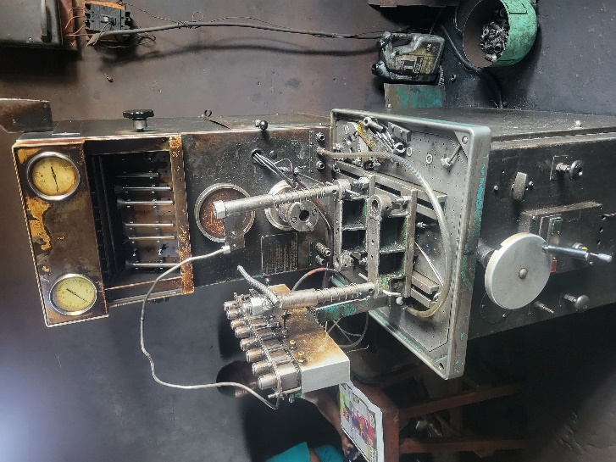 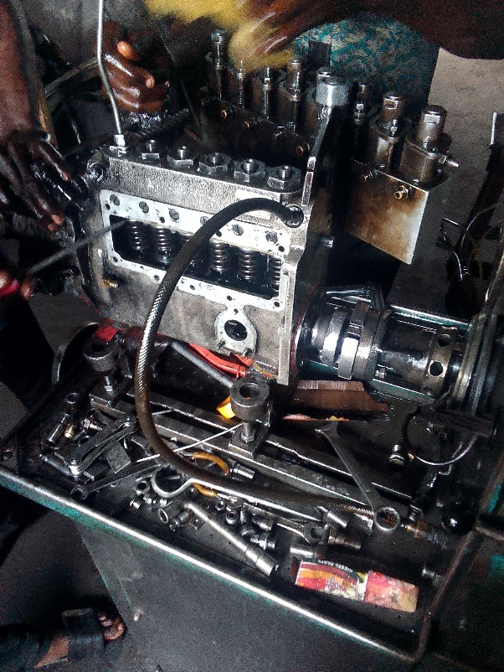

Plate : Injector Calibration Machine Plate : Injector Calibration operations

### 3.5.2 MILLING OPERATIONS

Milling was used for various machining tasks requiring flat, precise surfaces or specific features.

**Common milling operations observed:**

* **Cylinder head resurfacing:** Removing warpage and achieving flat mating surface between head and block
* **Engine block deck surfacing:** Correcting deck warpage to ensure proper head gasket sealing
* **Keyway cutting:** Machining keyways in shafts for pulley and gear installation
* **Slot milling:** Creating slots for various mechanical components

**Equipment used:**

* Vertical milling machine with various cutting tools
* Fly cutter for large flat surfaces
* End mills for slots and pockets
* Dial indicator for setup and verification

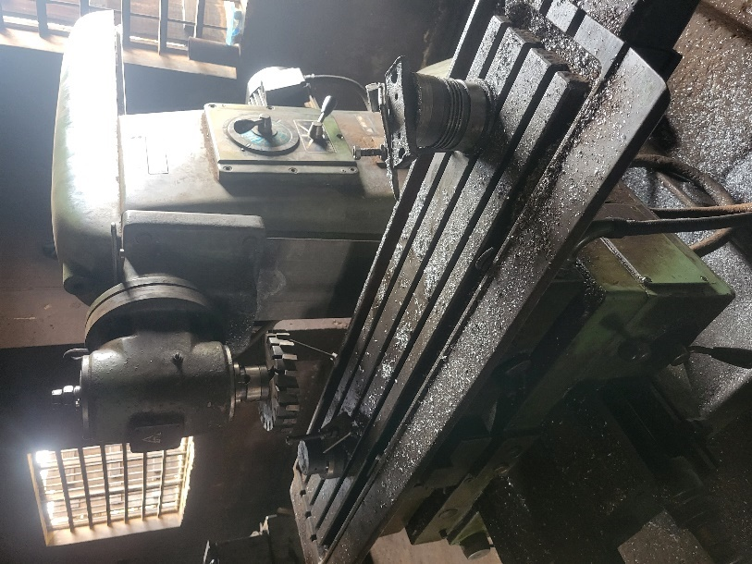

Plate : Milling Machine

**Process emphasis:**

* Proper workpiece clamping to prevent movement during cutting
* Accurate measurement before and after machining to verify material removal
* Coolant application for heat control and surface finish
* Taking light finishing passes for dimensional accuracy

# CHAPTER FOUR

## 4.0 CONCLUSION AND RECOMMENDATIONS

## 4.1 CONCLUSION

The SIWES program provided invaluable hands-on experience in various aspects of mechanical engineering, including machining engine blocks, injector repair works, and welding and fabrication processes. Throughout the program, practical skills were honed, and theoretical knowledge was put into practice, resulting in a deeper understanding of industrial processes and applications. The experience gained in machining engine blocks allowed for the precise shaping and finishing of metal components, essential for ensuring the optimal performance of machinery and engines. Furthermore, participating in injector repair works provided insight into the intricate workings of fuel injection systems, highlighting the importance of precision and attention to detail in maintaining engine efficiency.

Moreover, involvement in welding and fabrication tasks underscored the significance of structural integrity and material properties in manufacturing processes. From cutting and shaping metal components to joining them together securely, the fabrication process emphasized the importance of craftsmanship and adherence to industry standards.

Overall, the SIWES program offered a comprehensive learning experience, bridging the gap between theoretical knowledge and practical application in the field of mechanical engineering. The acquired skills and experiences will undoubtedly serve as a solid foundation for future endeavors in the industry, contributing to professional growth and development in the field.

## 4.2 RECOMMENDATION

Based on the experiences gained during the SIWES program, the following recommendations are

proposed:

**To FUTA:**

I. The institution should provide means for appropriate recommendation of students to industries to ease the difficulties and delays in searching for placements.

II. The institution could include attending workshops, seminars, or specialized training courses to the syllabus to stay updated on industry advancements and best practices.

To Host Company:

I. The company should prioritize safety protocols and practices ensuring that all personnel are equipped with the necessary personal protective equipment (PPE) and are trained in safe handling and operation of machinery and equipment.

II. The company should implement stringent quality assurance measures to maintain high standards of workmanship and product integrity.

**To SIWES:**

I. SIWES should ensure that there is provision of fund available for students to cater for immediate needs such as transportation for ease during the training.

II. Government, institutions and industries should encourage research and innovation in mechanical engineering practices. Investing in research and development initiatives can lead to the discovery of new methodologies, materials, and technologies that can improve efficiency, productivity, and sustainability in the field.

# REFERENCE:

Hart's Diesel & Machine. (n.d.). Our Replacement Parts for Diesel Fuel Injector Pumps. Retrieved November 28, 2025, from <https://www.hartsdiesel.com/fuel-injection-pumps>

Nigerian Institute of Welding. (2023). Best Practices in Welding [online]. NIW. Retrieved from https://niw.ng/

Primesource. (2023, December 22). What is the Difference Between Welding and Fabrication?

Retrieved December 1, 2025, from

<https://primesourceco.com/latest-news/what-is-the-difference-between-welding-and-fabrication/>

Student Industrial Work Experience Scheme. (2023). About Us [online]. SIWES. Retrieved from https:/[/www.siwes.itf.gov.ng/Identity/LandingPage/About](http://www.siwes.itf.gov.ng/Identity/LandingPage/About)

TechniWaterjet. (n.d.). What is Machining: Definition, Stages & Applications. Retrieved November 25, 2024, from <https://www.techniwaterjet.com/machining/>